**WEEK-2 PL/SQL EXERCISES**

**Exercise 1: Control Structures**

**Scenario 1:** The bank wants to apply a discount to loan interest rates for customers above 60 years old.

**Question:** Write a PL/SQL block that loops through all customers, checks their age, and if they are above 60, apply a 1% discount to their current loan interest rates.

**Query:**

BEGIN

FOR cust IN (

SELECT CustomerID

FROM Customers

WHERE MONTHS_BETWEEN(SYSDATE, DOB) / 12 > 60

) LOOP

UPDATE Loans

SET InterestRate = InterestRate - 1

WHERE CustomerID = cust.CustomerID;

END LOOP;

END;

/

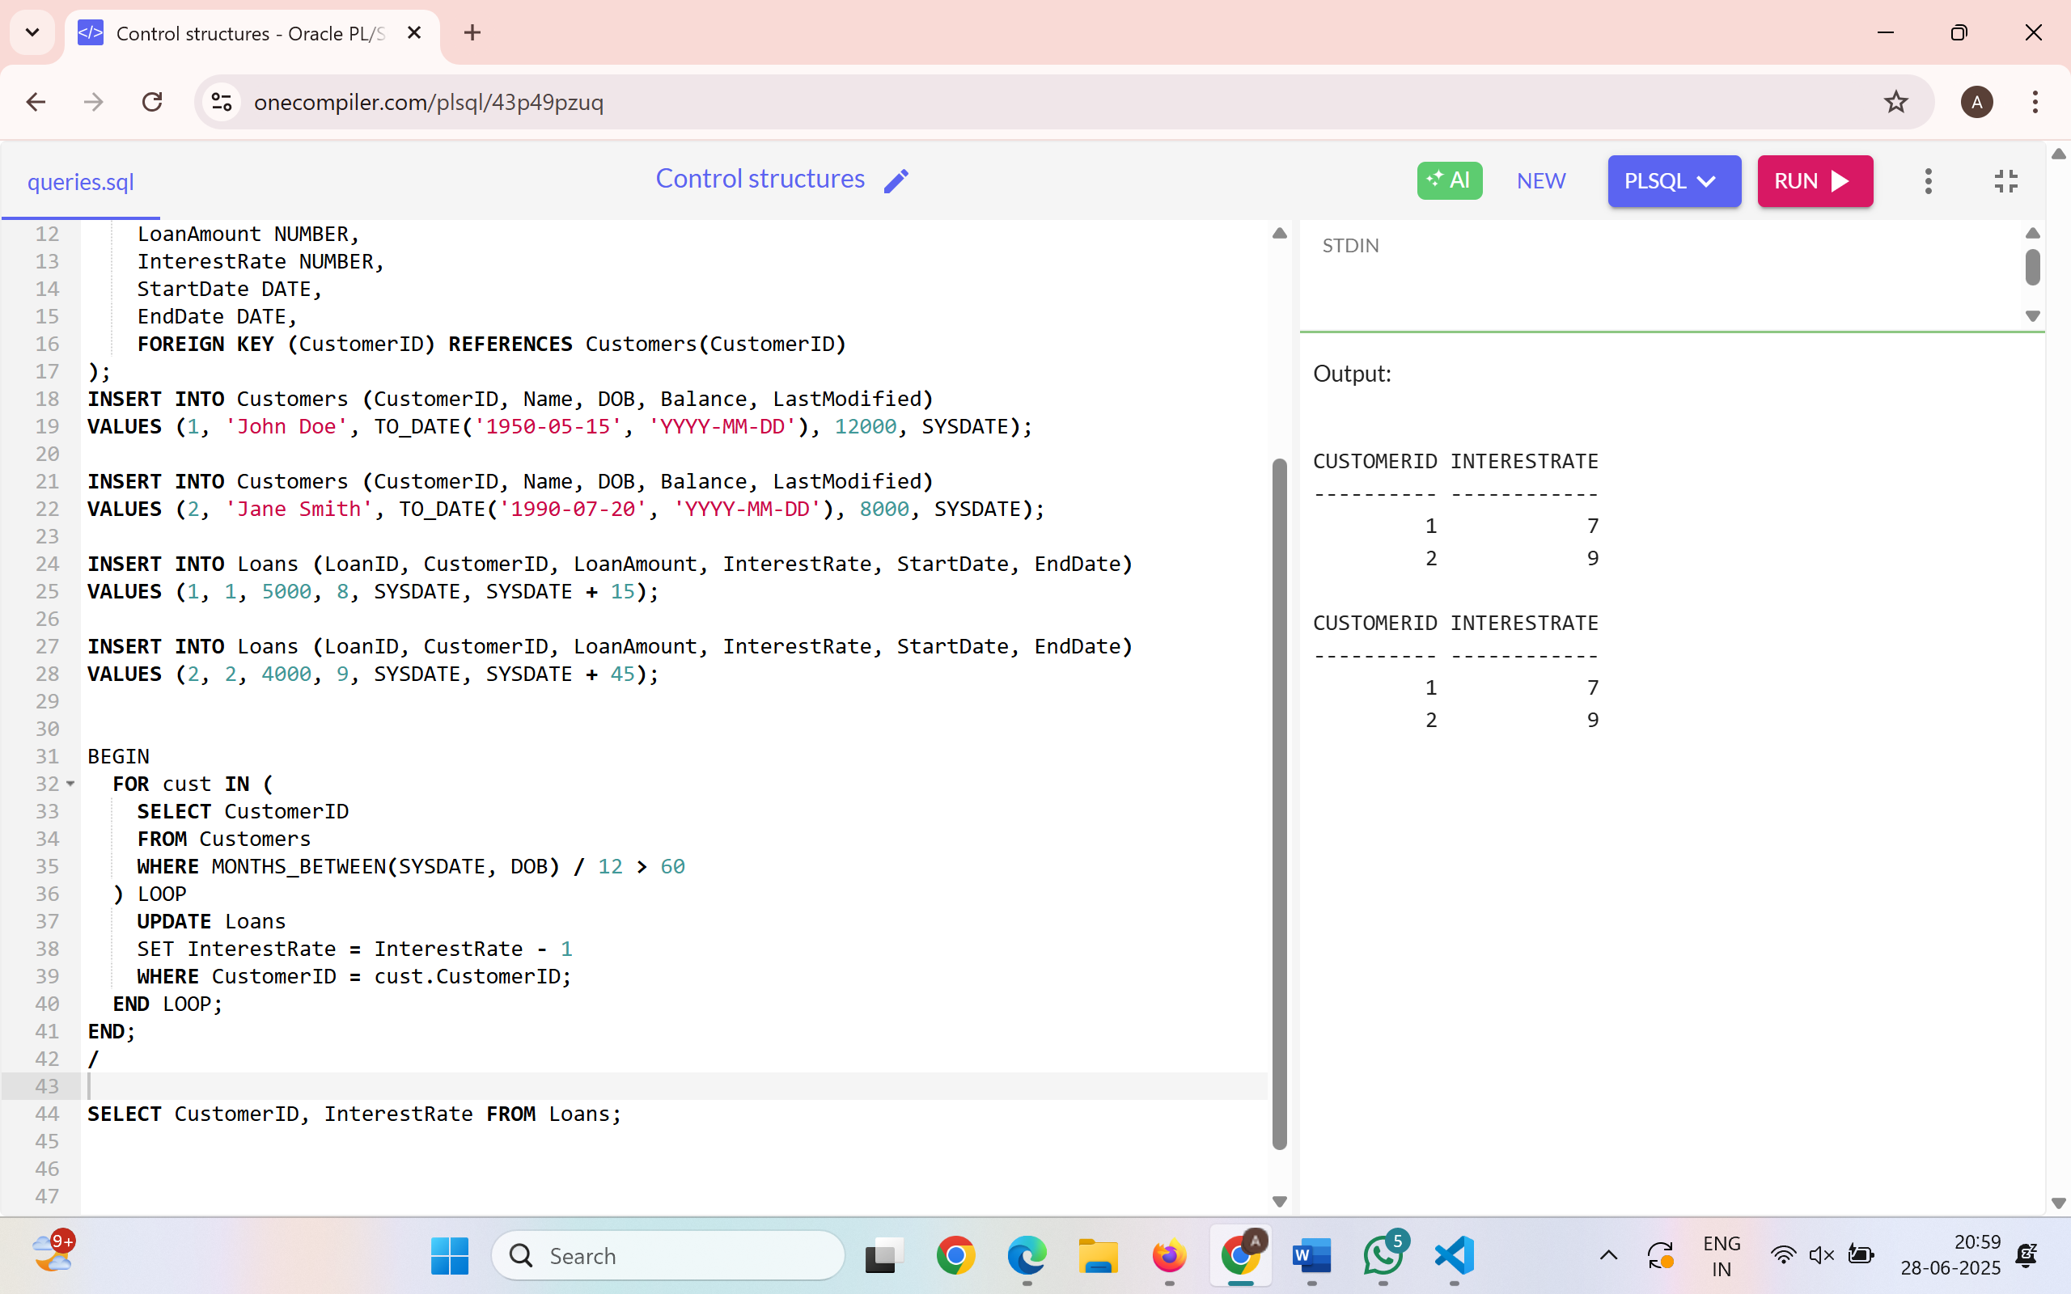

**Scenario 2:** A customer can be promoted to VIP status based on their balance.

**Question:** Write a PL/SQL block that iterates through all customers and sets a flag IsVIP to TRUE for those with a balance over $10,000.

**Query:**

BEGIN

FOR cust IN (

SELECT CustomerID, Balance FROM Customers

) LOOP

IF cust.Balance > 10000 THEN

UPDATE Customers

SET IsVIP = 'TRUE'

WHERE CustomerID = cust.CustomerID;

END IF;

END LOOP;

END;

/

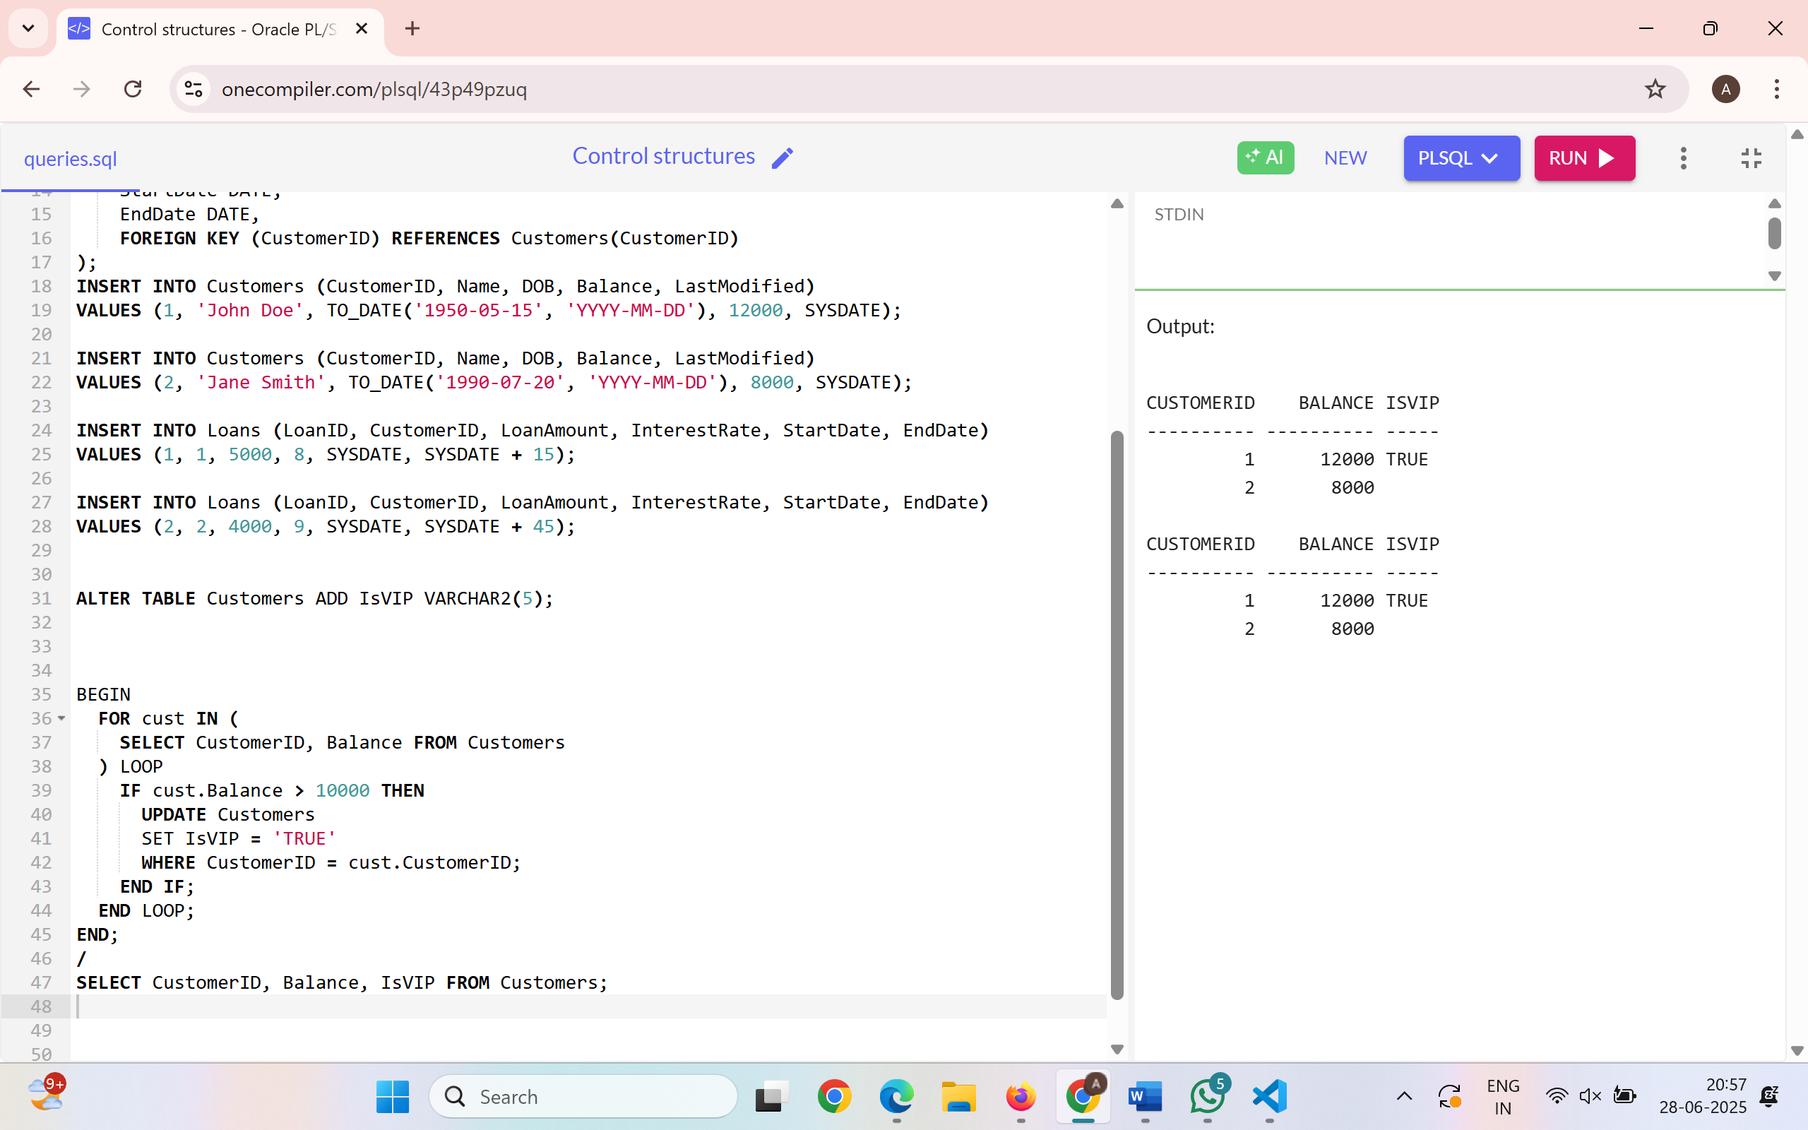

**Scenario 3:** The bank wants to send reminders to customers whose loans are due within the next 30 days.

**Question:** Write a PL/SQL block that fetches all loans due in the next 30 days and prints a reminder message for each customer.

**Query:**

SET SERVEROUTPUT ON;

BEGIN

FOR loan_rec IN (

SELECT L.LoanID, C.Name, L.EndDate

FROM Loans L

JOIN Customers C ON L.CustomerID = C.CustomerID

WHERE L.EndDate <= SYSDATE + 30

) LOOP

DBMS_OUTPUT.PUT_LINE('Reminder: Dear ' || loan_rec.Name || ', your loan (ID: ' || loan_rec.LoanID || ') is due on ' || TO_CHAR(loan_rec.EndDate, 'DD-MON-YYYY'));

END LOOP;

END;

/

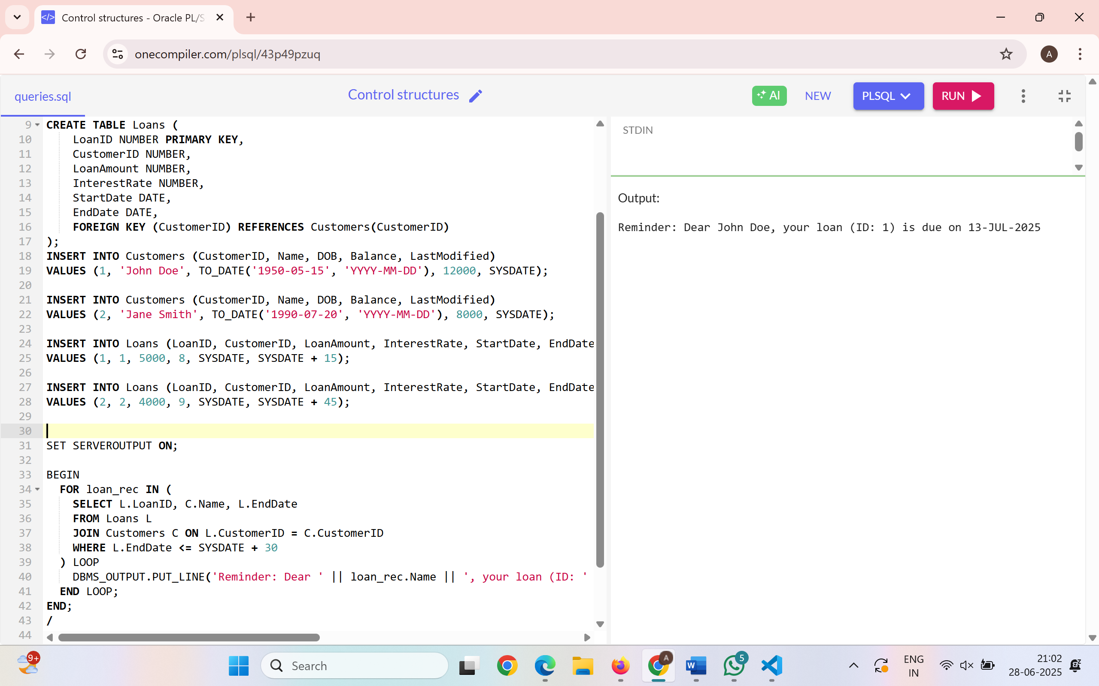

**Exercise 2: Error Handling**

**Scenario 1:** Handle exceptions during fund transfers between accounts.

**Question:** Write a stored procedure **SafeTransferFunds** that transfers funds between two accounts. Ensure that if any error occurs (e.g., insufficient funds), an appropriate error message is logged and the transaction is rolled back.

**Query:**

CREATE OR REPLACE PROCEDURE SafeTransferFunds (

p_from_acc_id IN NUMBER,

p_to_acc_id IN NUMBER,

p_amount IN NUMBER

) AS

v_from_balance NUMBER;

BEGIN

SELECT Balance INTO v_from_balance FROM Accounts WHERE AccountID = p_from_acc_id;

IF v_from_balance < p_amount THEN

RAISE_APPLICATION_ERROR(-20001, 'Insufficient funds in source account.');

END IF;

UPDATE Accounts SET Balance = Balance - p_amount WHERE AccountID = p_from_acc_id;

UPDATE Accounts SET Balance = Balance + p_amount WHERE AccountID = p_to_acc_id;

COMMIT;

DBMS_OUTPUT.PUT_LINE('Transfer successful.');

EXCEPTION

WHEN NO_DATA_FOUND THEN

DBMS_OUTPUT.PUT_LINE('Error: Invalid account ID.');

ROLLBACK;

WHEN OTHERS THEN

DBMS_OUTPUT.PUT_LINE('Transfer failed: ' || SQLERRM);

ROLLBACK;

END;

/

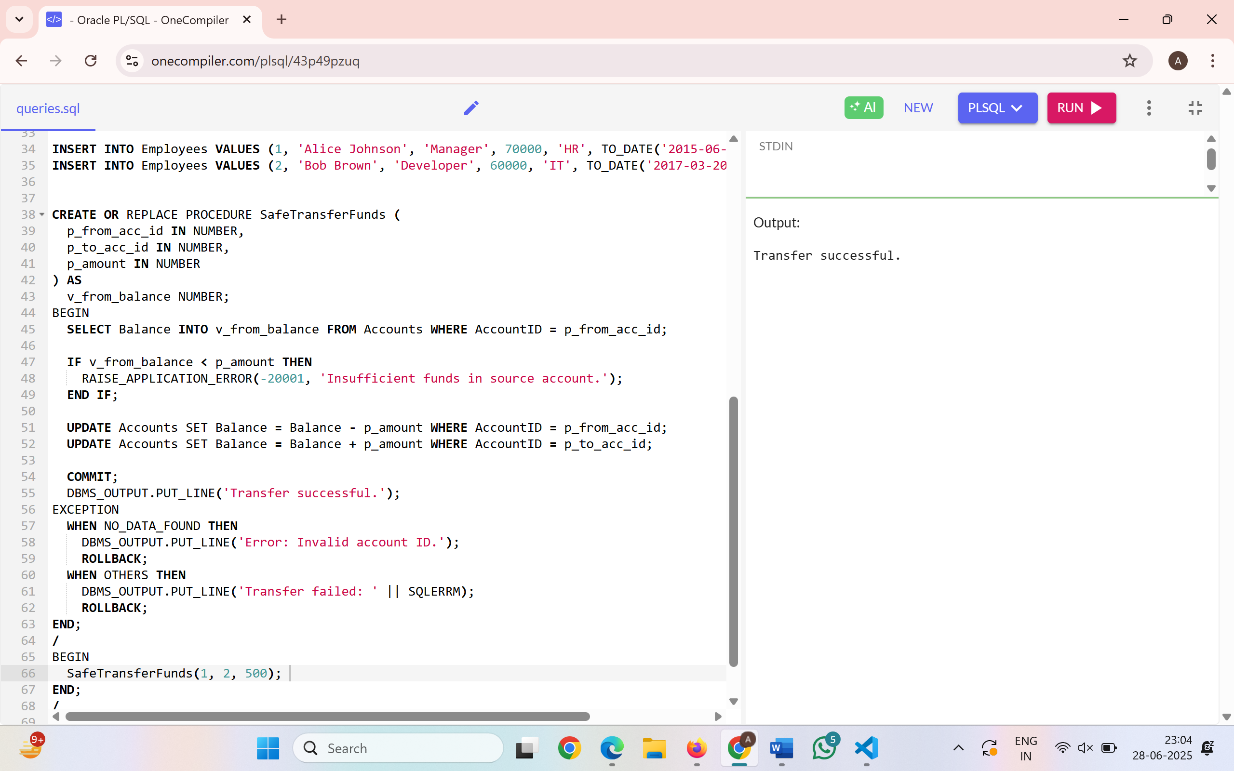

**Scenario 2:** Manage errors when updating employee salaries.

**Question:** Write a stored procedure **UpdateSalary** that increases the salary of an employee by a given percentage. If the employee ID does not exist, handle the exception and log an error message.

**Query:**

CREATE OR REPLACE PROCEDURE UpdateSalary (

p_emp_id IN NUMBER,

p_percent IN NUMBER

) AS

BEGIN

UPDATE Employees

SET Salary = Salary + (Salary * p_percent / 100)

WHERE EmployeeID = p_emp_id;

IF SQL%ROWCOUNT = 0 THEN

RAISE_APPLICATION_ERROR(-20002, 'Employee ID not found.');

END IF;

COMMIT;

DBMS_OUTPUT.PUT_LINE('Salary updated successfully.');

EXCEPTION

WHEN OTHERS THEN

DBMS_OUTPUT.PUT_LINE('Error updating salary: ' || SQLERRM);

ROLLBACK;

END;

/

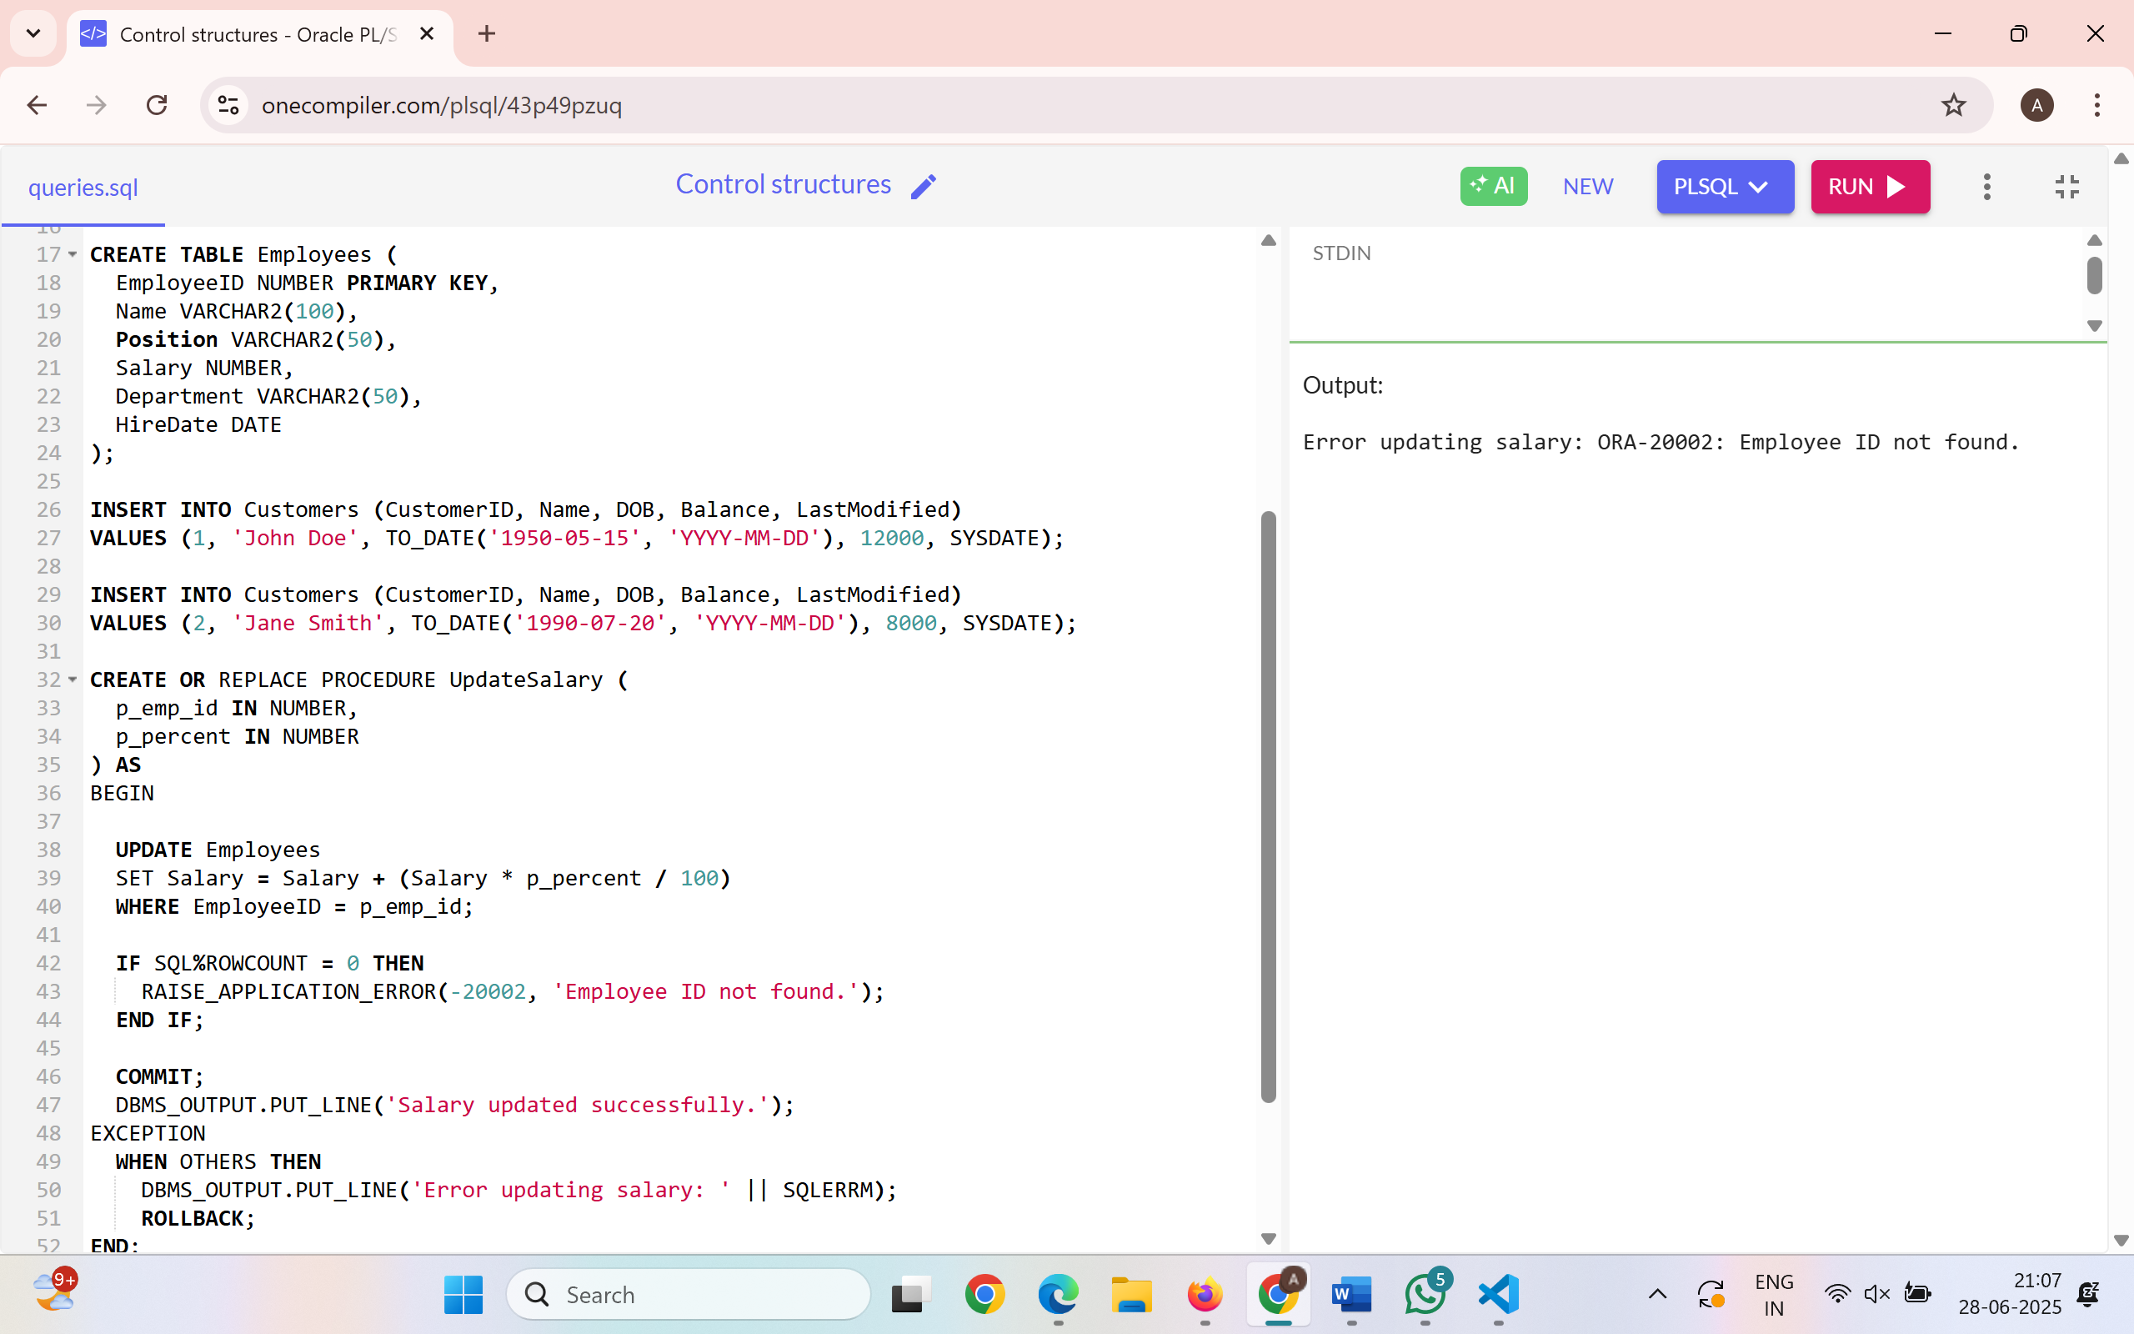

**Scenario 3:** Ensure data integrity when adding a new customer.

**Question:** Write a stored procedure **AddNewCustomer** that inserts a new customer into the Customers table. If a customer with the same ID already exists, handle the exception by logging an error and preventing the insertion.

**Query:**

CREATE OR REPLACE PROCEDURE AddNewCustomer (

p_cust_id IN NUMBER,

p_name IN VARCHAR2,

p_dob IN DATE,

p_balance IN NUMBER

) AS

BEGIN

INSERT INTO Customers (CustomerID, Name, DOB, Balance, LastModified)

VALUES (p_cust_id, p_name, p_dob, p_balance, SYSDATE);

COMMIT;

DBMS_OUTPUT.PUT_LINE('Customer added successfully.');

EXCEPTION

WHEN DUP_VAL_ON_INDEX THEN

DBMS_OUTPUT.PUT_LINE('Error: Customer ID already exists.');

ROLLBACK;

WHEN OTHERS THEN

DBMS_OUTPUT.PUT_LINE('Unexpected error: ' || SQLERRM);

ROLLBACK;

END;

/

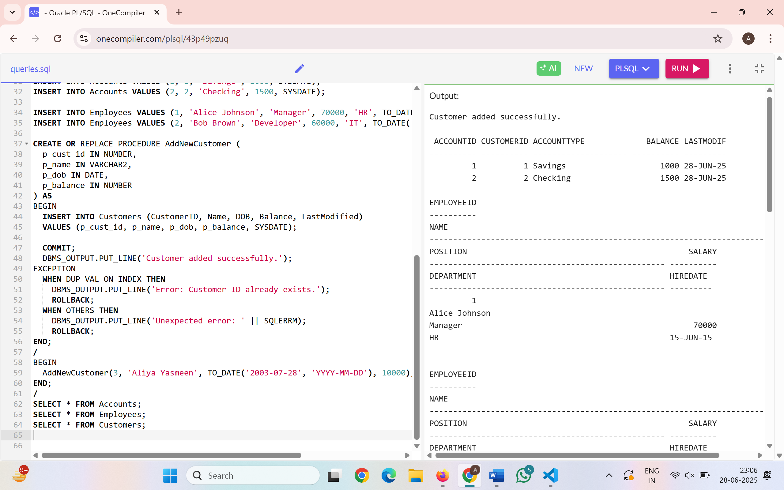

**Exercise 3: Stored Procedures**

**Scenario 1:** The bank needs to process monthly interest for all savings accounts.

**Question:** Write a stored procedure **ProcessMonthlyInterest** that calculates and updates the balance of all savings accounts by applying an interest rate of 1% to the current balance.

**Query:**

CREATE OR REPLACE PROCEDURE ProcessMonthlyInterest IS

BEGIN

UPDATE Accounts

SET Balance = Balance + (Balance * 0.01),

LastModified = SYSDATE

WHERE AccountType = 'Savings';

COMMIT;

DBMS_OUTPUT.PUT_LINE(' Monthly interest applied to all savings accounts.');

EXCEPTION

WHEN OTHERS THEN

DBMS_OUTPUT.PUT_LINE(' Error: ' || SQLERRM);

ROLLBACK;

END;

/

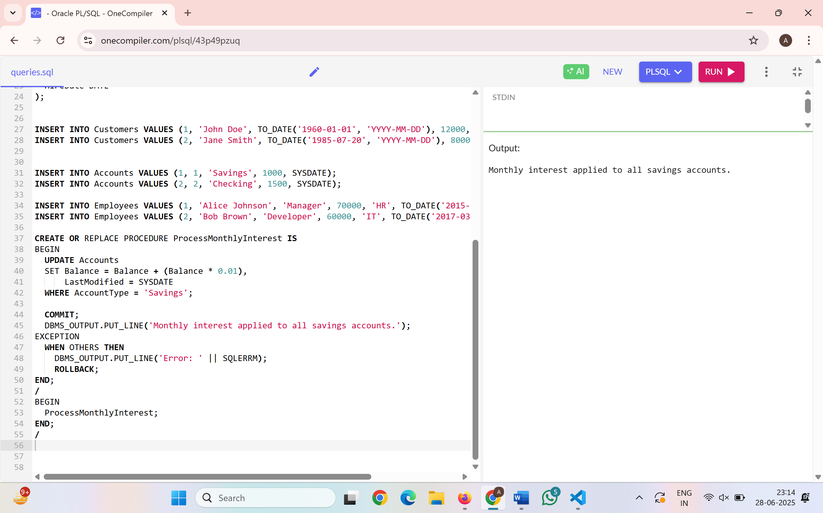

**Scenario 2:** The bank wants to implement a bonus scheme for employees based on their performance.

**Question:** Write a stored procedure **UpdateEmployeeBonus** that updates the salary of employees in a given department by adding a bonus percentage passed as a parameter.

**Query:**

CREATE OR REPLACE PROCEDURE UpdateEmployeeBonus (

p_department IN VARCHAR2,

p_bonus_percent IN NUMBER

) AS

BEGIN

UPDATE Employees

SET Salary = Salary + (Salary * p_bonus_percent / 100)

WHERE Department = p_department;

IF SQL%ROWCOUNT = 0 THEN

DBMS_OUTPUT.PUT_LINE(' No employees found in ' || p_department || ' department.');

ELSE

DBMS_OUTPUT.PUT_LINE(' Bonus applied to ' || SQL%ROWCOUNT || ' employee(s) in ' || p_department || ' department.');

END IF;

COMMIT;

EXCEPTION

WHEN OTHERS THEN

DBMS_OUTPUT.PUT_LINE(' Error: ' || SQLERRM);

ROLLBACK;

END;

/

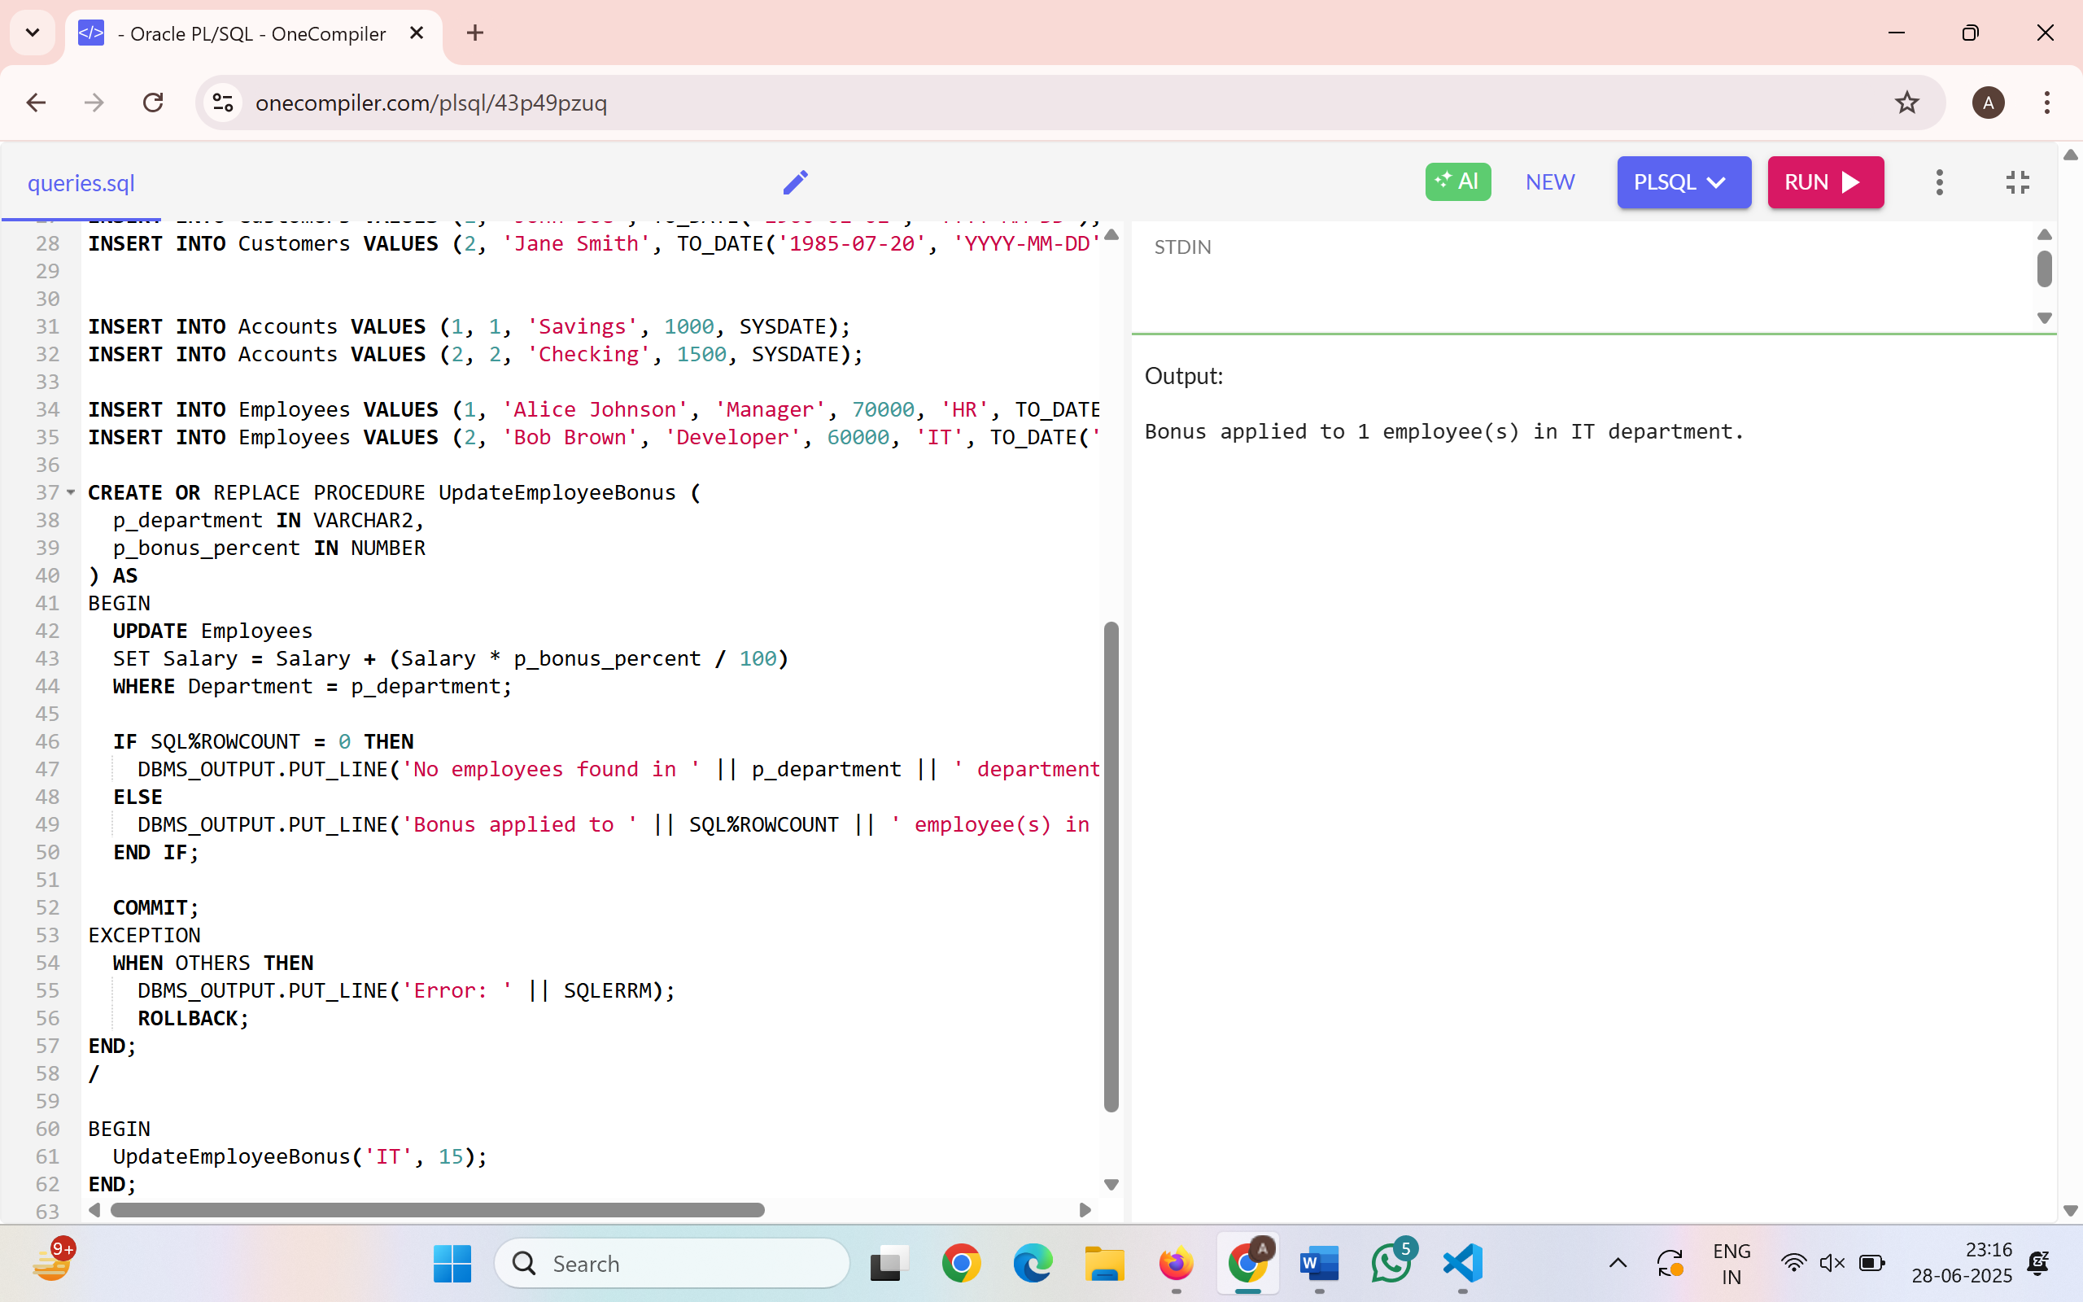

**Scenario 3:** Customers should be able to transfer funds between their accounts.

**Question:** Write a stored procedure **TransferFunds** that transfers a specified amount from one account to another, checking that the source account has sufficient balance before making the transfer.

**Query:**

CREATE OR REPLACE PROCEDURE TransferFunds (

p_from_acc_id IN NUMBER,

p_to_acc_id IN NUMBER,

p_amount IN NUMBER

) AS

v_balance NUMBER;

BEGIN

SELECT Balance INTO v_balance FROM Accounts WHERE AccountID = p_from_acc_id;

IF v_balance < p_amount THEN

RAISE_APPLICATION_ERROR(-20001, 'Insufficient balance in source account.');

END IF;

UPDATE Accounts

SET Balance = Balance - p_amount,

LastModified = SYSDATE

WHERE AccountID = p_from_acc_id;

UPDATE Accounts

SET Balance = Balance + p_amount,

LastModified = SYSDATE

WHERE AccountID = p_to_acc_id;

COMMIT;

DBMS_OUTPUT.PUT_LINE(' Funds transferred successfully.');

EXCEPTION

WHEN NO_DATA_FOUND THEN

DBMS_OUTPUT.PUT_LINE(' One or both account IDs not found.');

ROLLBACK;

WHEN OTHERS THEN

DBMS_OUTPUT.PUT_LINE(' Error during transfer: ' || SQLERRM);

ROLLBACK;

END;

/

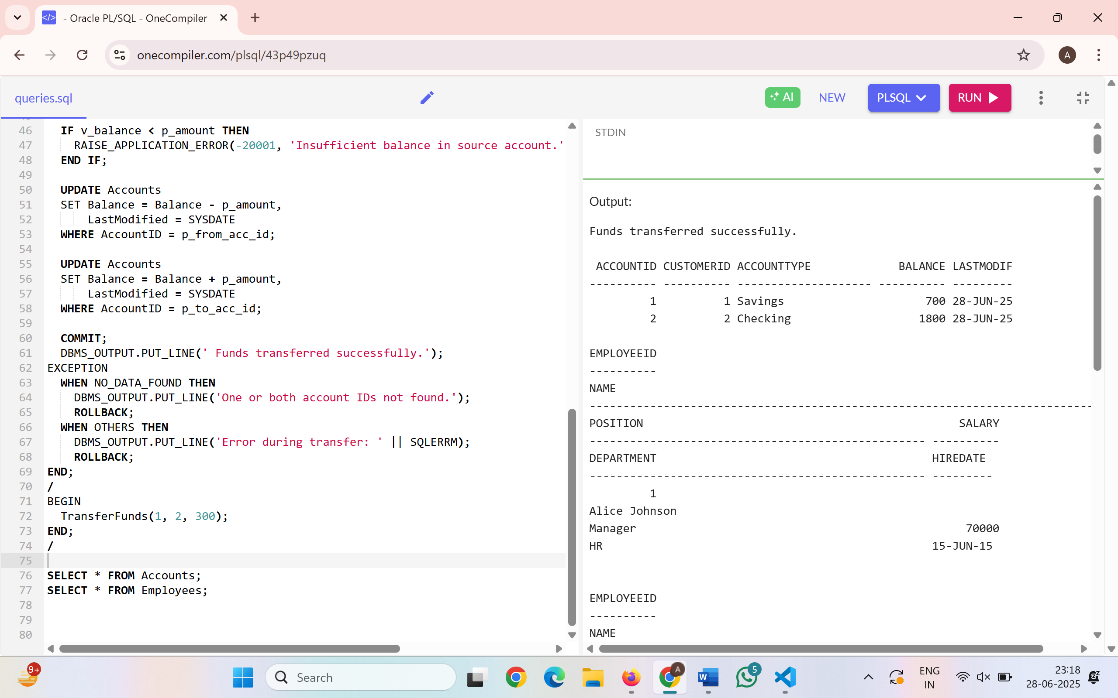

**Exercise 4: Functions**

**Scenario 1: Calculate the age of customers for eligibility checks.**

Question: Write a function CalculateAge that takes a customer's date of birth as input and returns their age in years.

**Query:**

CREATE OR REPLACE FUNCTION CalculateAge(p_dob DATE)

RETURN NUMBER IS

v_age NUMBER;

BEGIN

v_age := TRUNC(MONTHS_BETWEEN(SYSDATE, p_dob) / 12);

RETURN v_age;

END;

/

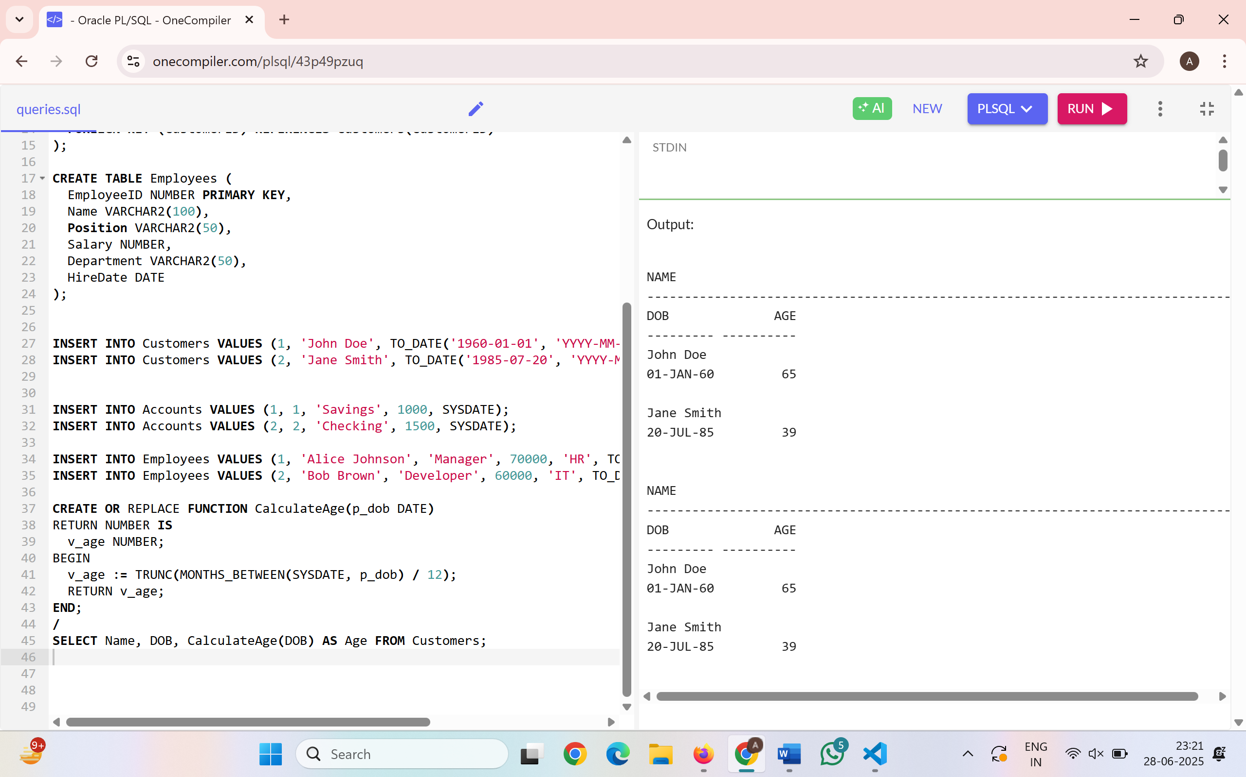

**Scenario 2: The bank needs to compute the monthly installment for a loan.**

**Question:** Write a function CalculateMonthlyInstallment that takes the loan amount, interest rate, and loan duration in years as input and returns the monthly installment amount**.**

**Query:**

CREATE OR REPLACE FUNCTION CalculateMonthlyInstallment (

p_amount IN NUMBER,

p_rate IN NUMBER,

p_years IN NUMBER

) RETURN NUMBER IS

v_monthly_rate NUMBER := p_rate / (12 * 100);

v_months NUMBER := p_years * 12;

v_emi NUMBER;

BEGIN

v_emi := (p_amount * v_monthly_rate) / (1 - POWER(1 + v_monthly_rate, -v_months));

RETURN ROUND(v_emi, 2);

END;

/

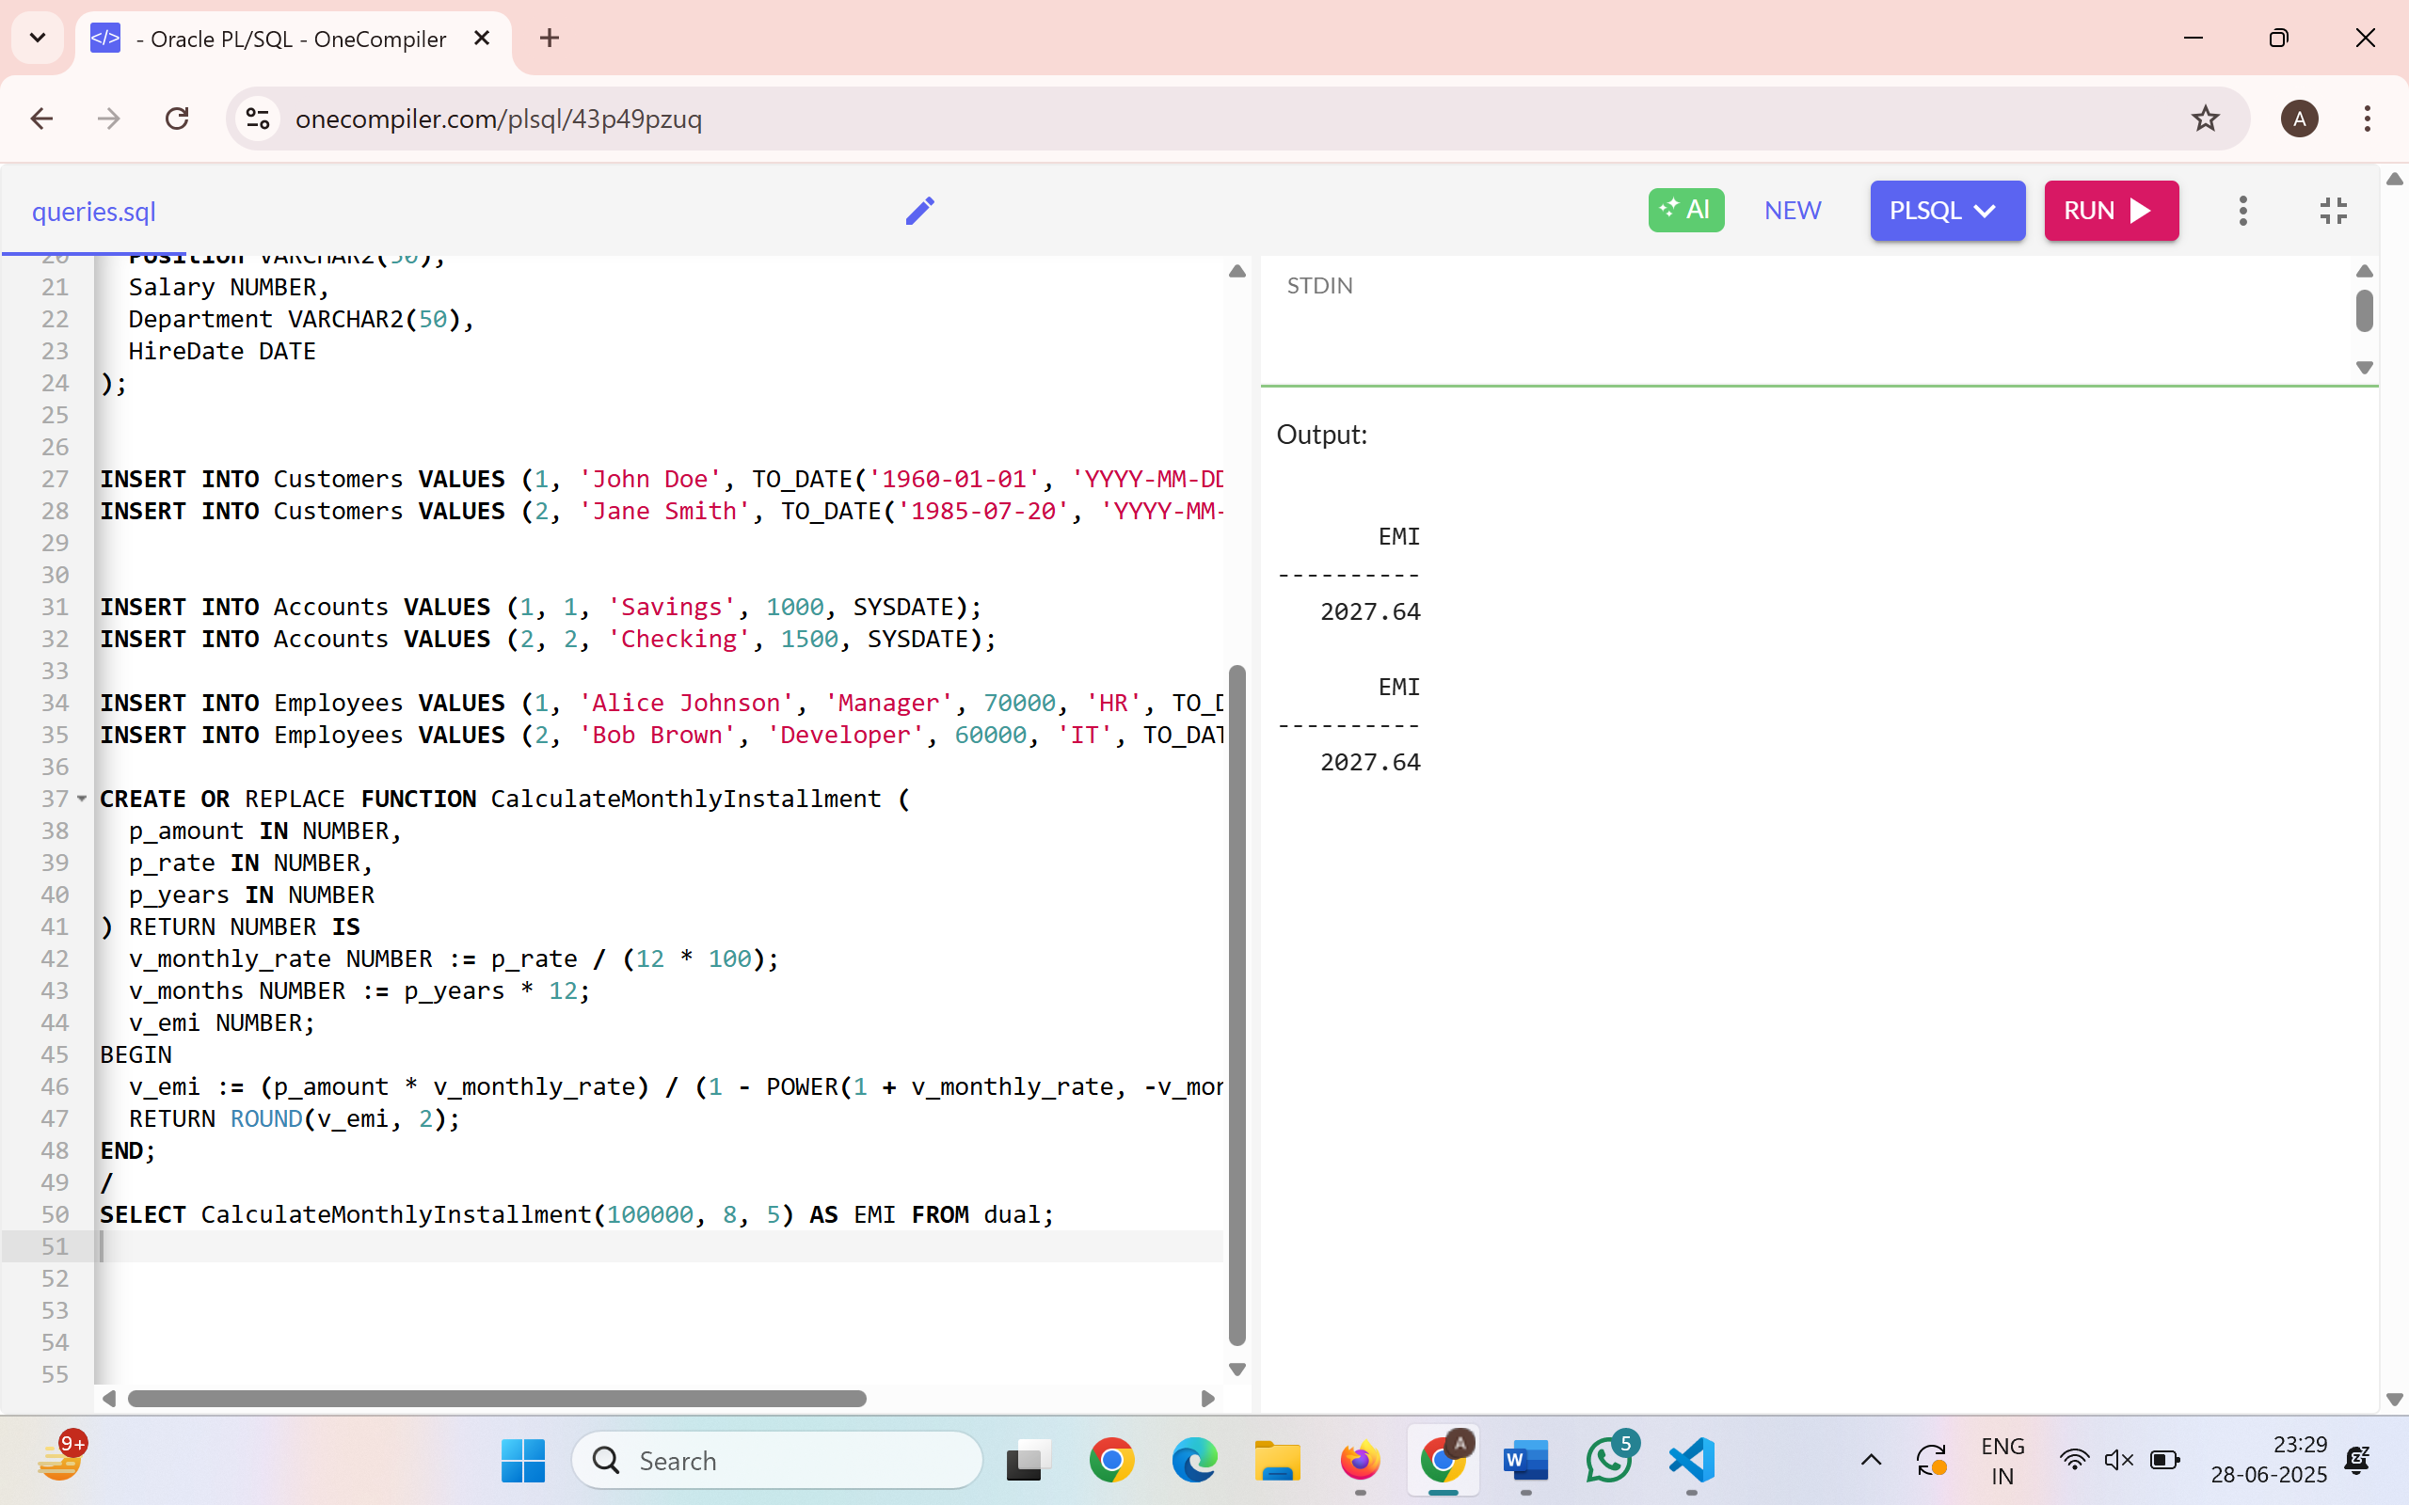

**Scenario 3: Check if a customer has sufficient balance before making a transaction.**

**Question:** Write a function HasSufficientBalance that takes an account ID and an amount as input and returns a boolean indicating whether the account has at least the specified amount.

**Query:**

CREATE OR REPLACE FUNCTION HasSufficientBalance (

p_acc_id IN NUMBER,

p_amount IN NUMBER

) RETURN VARCHAR2 IS

v_balance NUMBER;

BEGIN

SELECT Balance INTO v_balance FROM Accounts WHERE AccountID = p_acc_id;

IF v_balance >= p_amount THEN

RETURN 'TRUE';

ELSE

RETURN 'FALSE';

END IF;

EXCEPTION

WHEN NO_DATA_FOUND THEN

RETURN 'Account Not Found';

END;

/

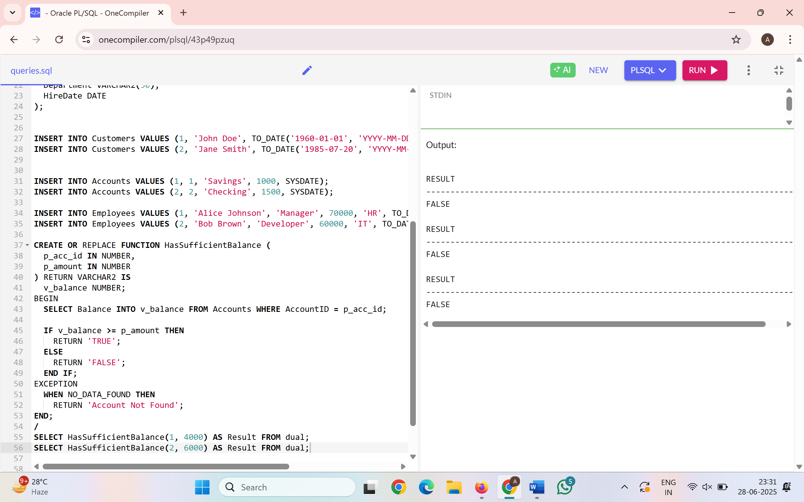

**Exercise 5: Triggers**

**Scenario 1:** Automatically update the last modified date when a customer's record is updated.

**Question:** Write a trigger **UpdateCustomerLastModified** that updates the LastModified column of the Customers table to the current date whenever a customer's record is updated

**Query:**

CREATE OR REPLACE TRIGGER UpdateCustomerLastModified

BEFORE UPDATE ON Customers

FOR EACH ROW

BEGIN

:NEW.LastModified := SYSDATE;

END;

/

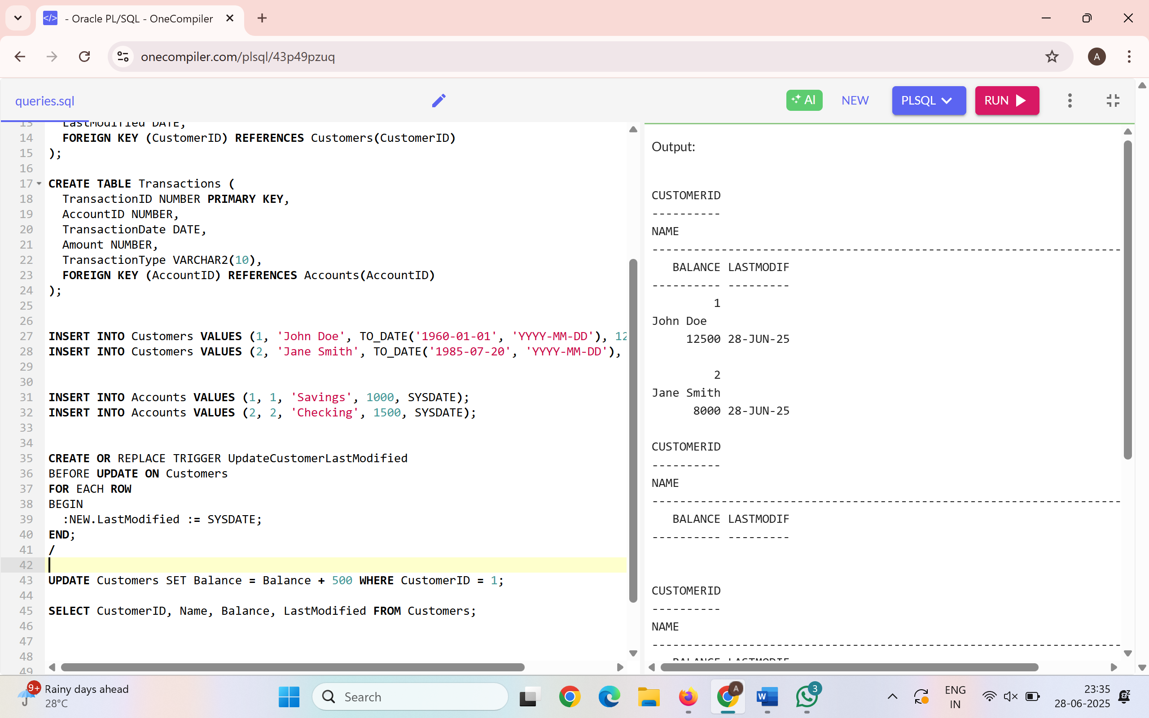

**Scenario 2:** Maintain an audit log for all transactions.

**Question:** Write a trigger **LogTransaction** that inserts a record into an AuditLog table whenever a transaction is inserted into the Transactions table.

**Query:**

CREATE OR REPLACE TRIGGER LogTransaction

AFTER INSERT ON Transactions

FOR EACH ROW

BEGIN

INSERT INTO AuditLog (TransactionID, LogDate, Message)

VALUES (:NEW.TransactionID, SYSDATE, 'Transaction inserted for Account ID: ' || :NEW.AccountID);

END;

/

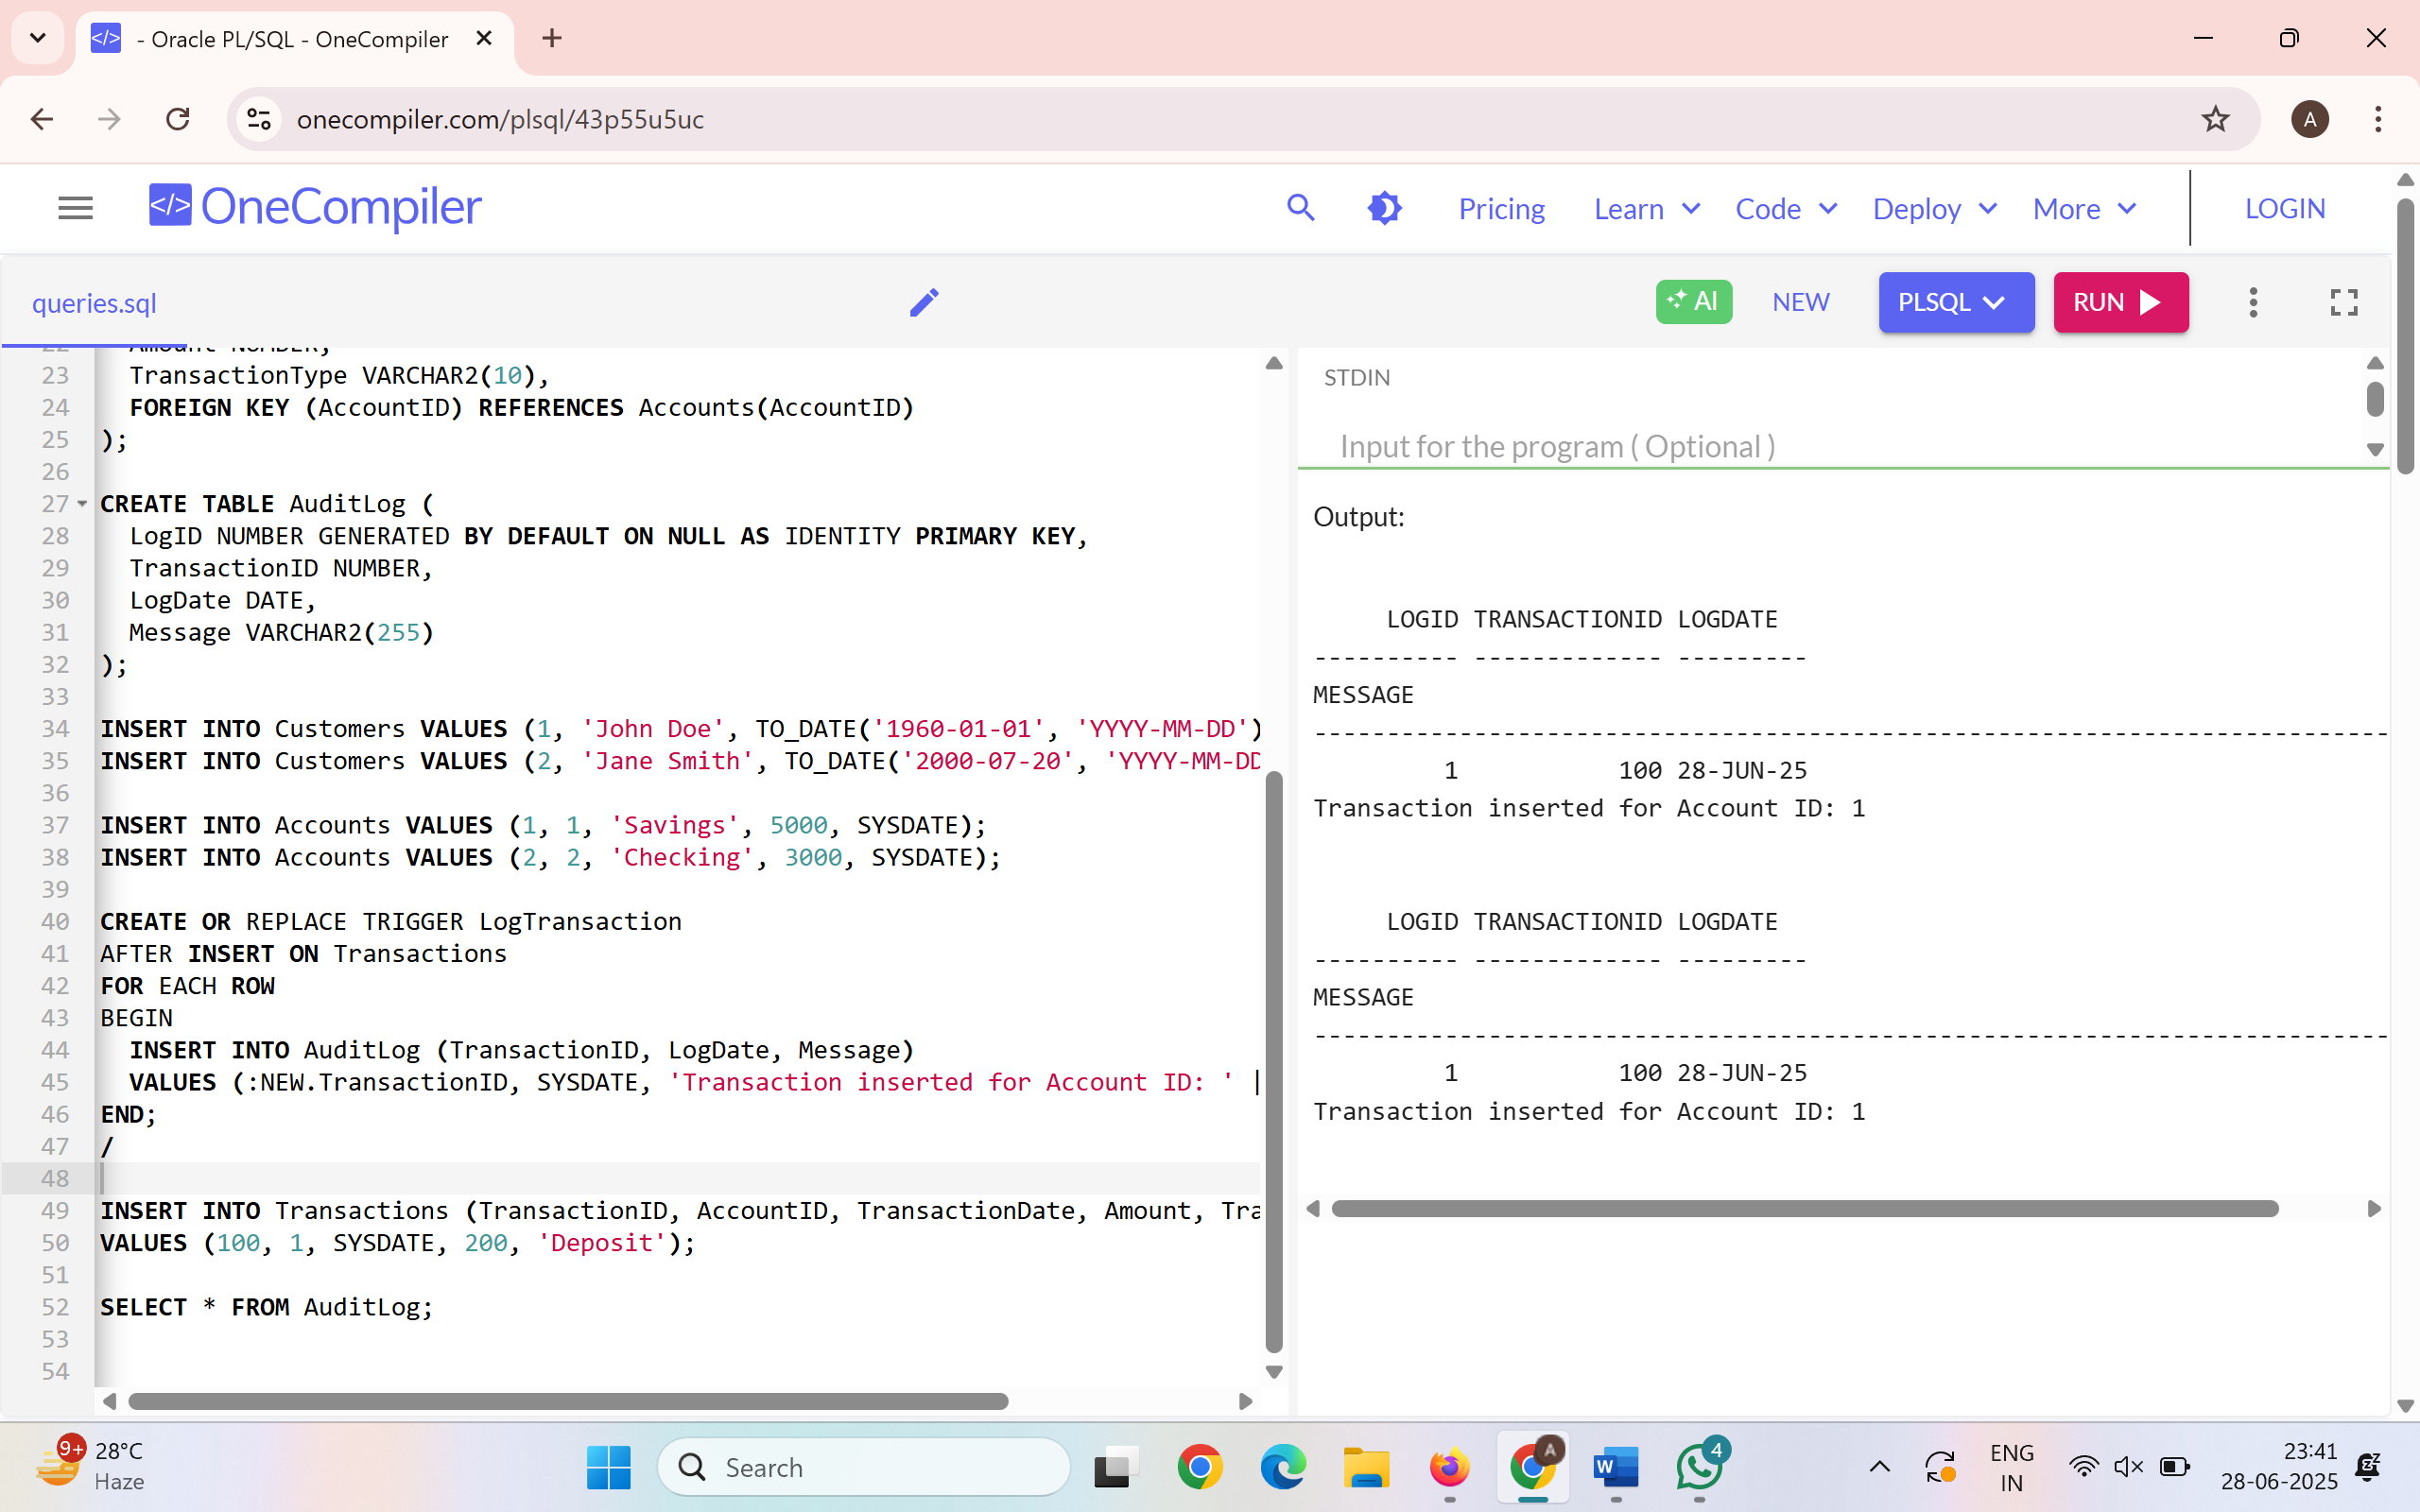

**Scenario 3:** Enforce business rules on deposits and withdrawals.

**Question:** Write a trigger **CheckTransactionRules** that ensures withdrawals do not exceed the balance and deposits are positive before inserting a record into the Transactions table.

**Query:**

CREATE OR REPLACE TRIGGER CheckTransactionRules

BEFORE INSERT ON Transactions

FOR EACH ROW

DECLARE

v_balance NUMBER;

BEGIN

SELECT Balance INTO v_balance FROM Accounts WHERE AccountID = :NEW.AccountID;

IF :NEW.TransactionType = 'Withdrawal' AND :NEW.Amount > v_balance THEN

RAISE_APPLICATION_ERROR(-20001, 'Withdrawal exceeds balance.');

ELSIF :NEW.TransactionType = 'Deposit' AND :NEW.Amount <= 0 THEN

RAISE_APPLICATION_ERROR(-20002, 'Deposit must be positive.');

END IF;

END;

/

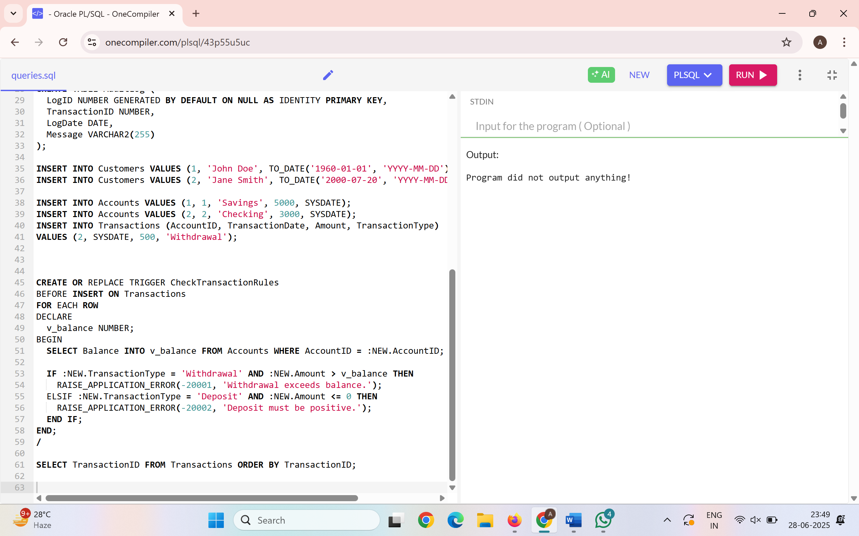

**Exercise 6: Cursors**

**Scenario 1:** Generate monthly statements for all customers.

**Question:** Write a PL/SQL block using an explicit cursor **GenerateMonthlyStatements** that retrieves all transactions for the current month and prints a statement for each customer.

**Query:**

BEGIN

DBMS_OUTPUT.PUT_LINE('--- Monthly Transaction Statements ---');

FOR rec IN (

SELECT c.Name, t.TransactionDate, t.TransactionType, t.Amount

FROM Customers c

JOIN Accounts a ON c.CustomerID = a.CustomerID

JOIN Transactions t ON a.AccountID = t.AccountID

WHERE TO_CHAR(t.TransactionDate, 'MMYYYY') = TO_CHAR(SYSDATE, 'MMYYYY')

) LOOP

DBMS_OUTPUT.PUT_LINE('Customer: ' || rec.Name ||

' | Date: ' || TO_CHAR(rec.TransactionDate, 'DD-MON-YY') ||

' | Type: ' || rec.TransactionType ||

' | Amount: ' || rec.Amount);

END LOOP;

END;

/

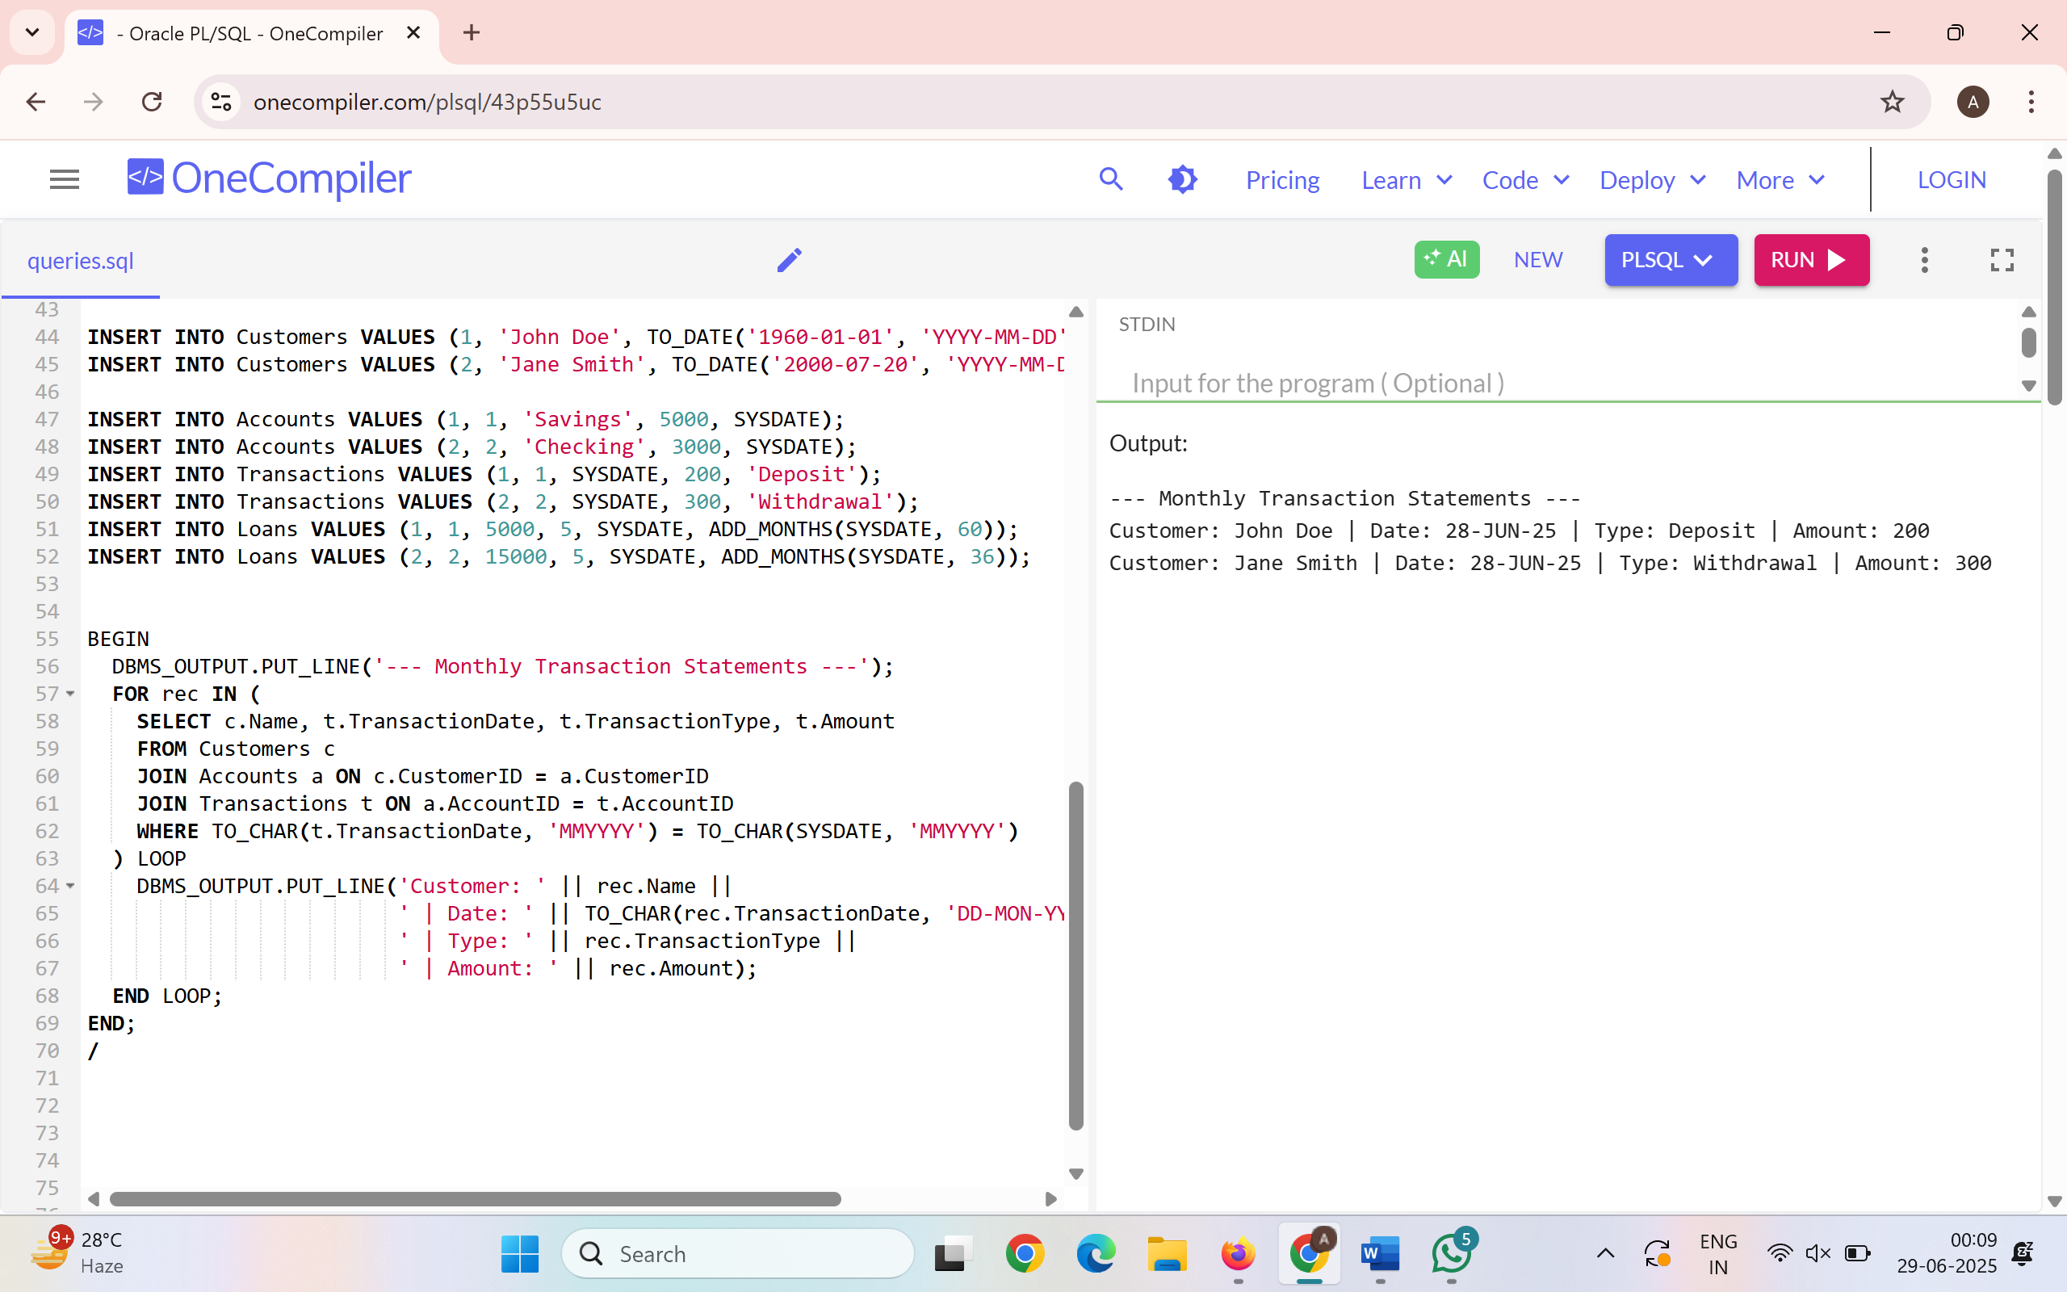

**Scenario 2:** Apply annual fee to all accounts.

**Question:** Write a PL/SQL block using an explicit cursor **ApplyAnnualFee** that deducts an annual maintenance fee from the balance of all accounts.

**Query:**

DECLARE

CURSOR acc_cursor IS SELECT AccountID FROM Accounts;

v_acc_id Accounts.AccountID%TYPE;

v_fee NUMBER := 500;

BEGIN

OPEN acc_cursor;

LOOP

FETCH acc_cursor INTO v_acc_id;

EXIT WHEN acc_cursor%NOTFOUND;

UPDATE Accounts SET Balance = Balance - v_fee WHERE AccountID = v_acc_id;

END LOOP;

CLOSE acc_cursor;

DBMS_OUTPUT.PUT_LINE('Annual fees deducted from all accounts.');

END;

/

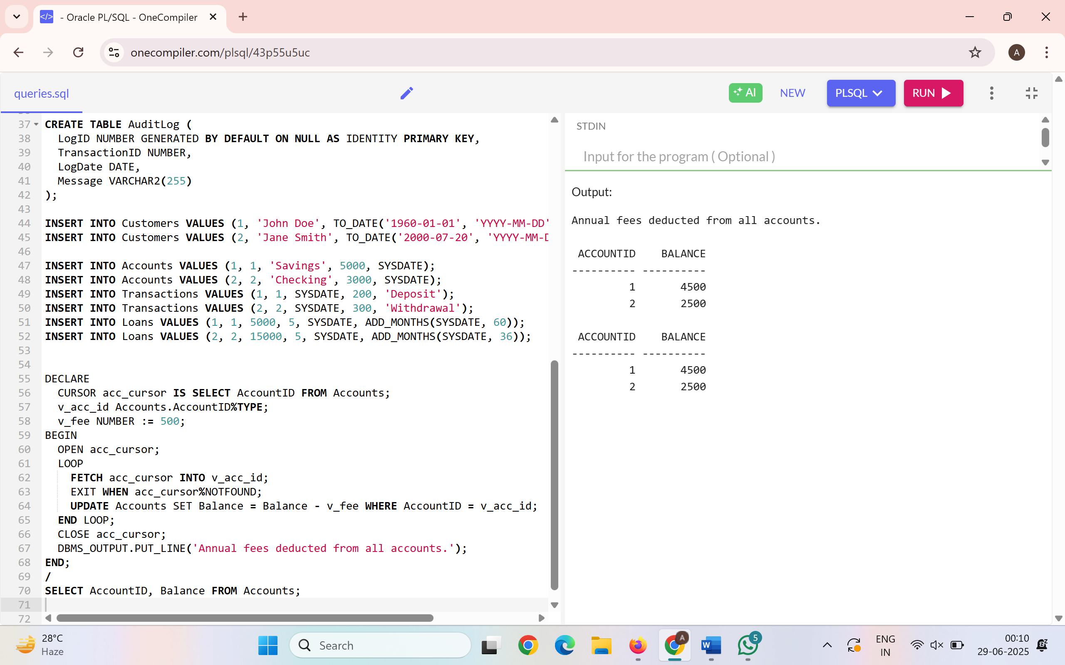

**Scenario 3:** Update the interest rate for all loans based on a new policy.

**Question:** Write a PL/SQL block using an explicit cursor **UpdateLoanInterestRates** that fetches all loans and updates their interest rates based on the new policy.

**Query:**

DECLARE

CURSOR loan_cursor IS SELECT LoanID, LoanAmount FROM Loans;

v_loan_id Loans.LoanID%TYPE;

v_amount Loans.LoanAmount%TYPE;

BEGIN

OPEN loan_cursor;

LOOP

FETCH loan_cursor INTO v_loan_id, v_amount;

EXIT WHEN loan_cursor%NOTFOUND;

IF v_amount > 10000 THEN

UPDATE Loans SET InterestRate = 6 WHERE LoanID = v_loan_id;

ELSE

UPDATE Loans SET InterestRate = 5 WHERE LoanID = v_loan_id;

END IF;

END LOOP;

CLOSE loan_cursor;

DBMS_OUTPUT.PUT_LINE('Interest rates updated as per new policy.');

END;

/

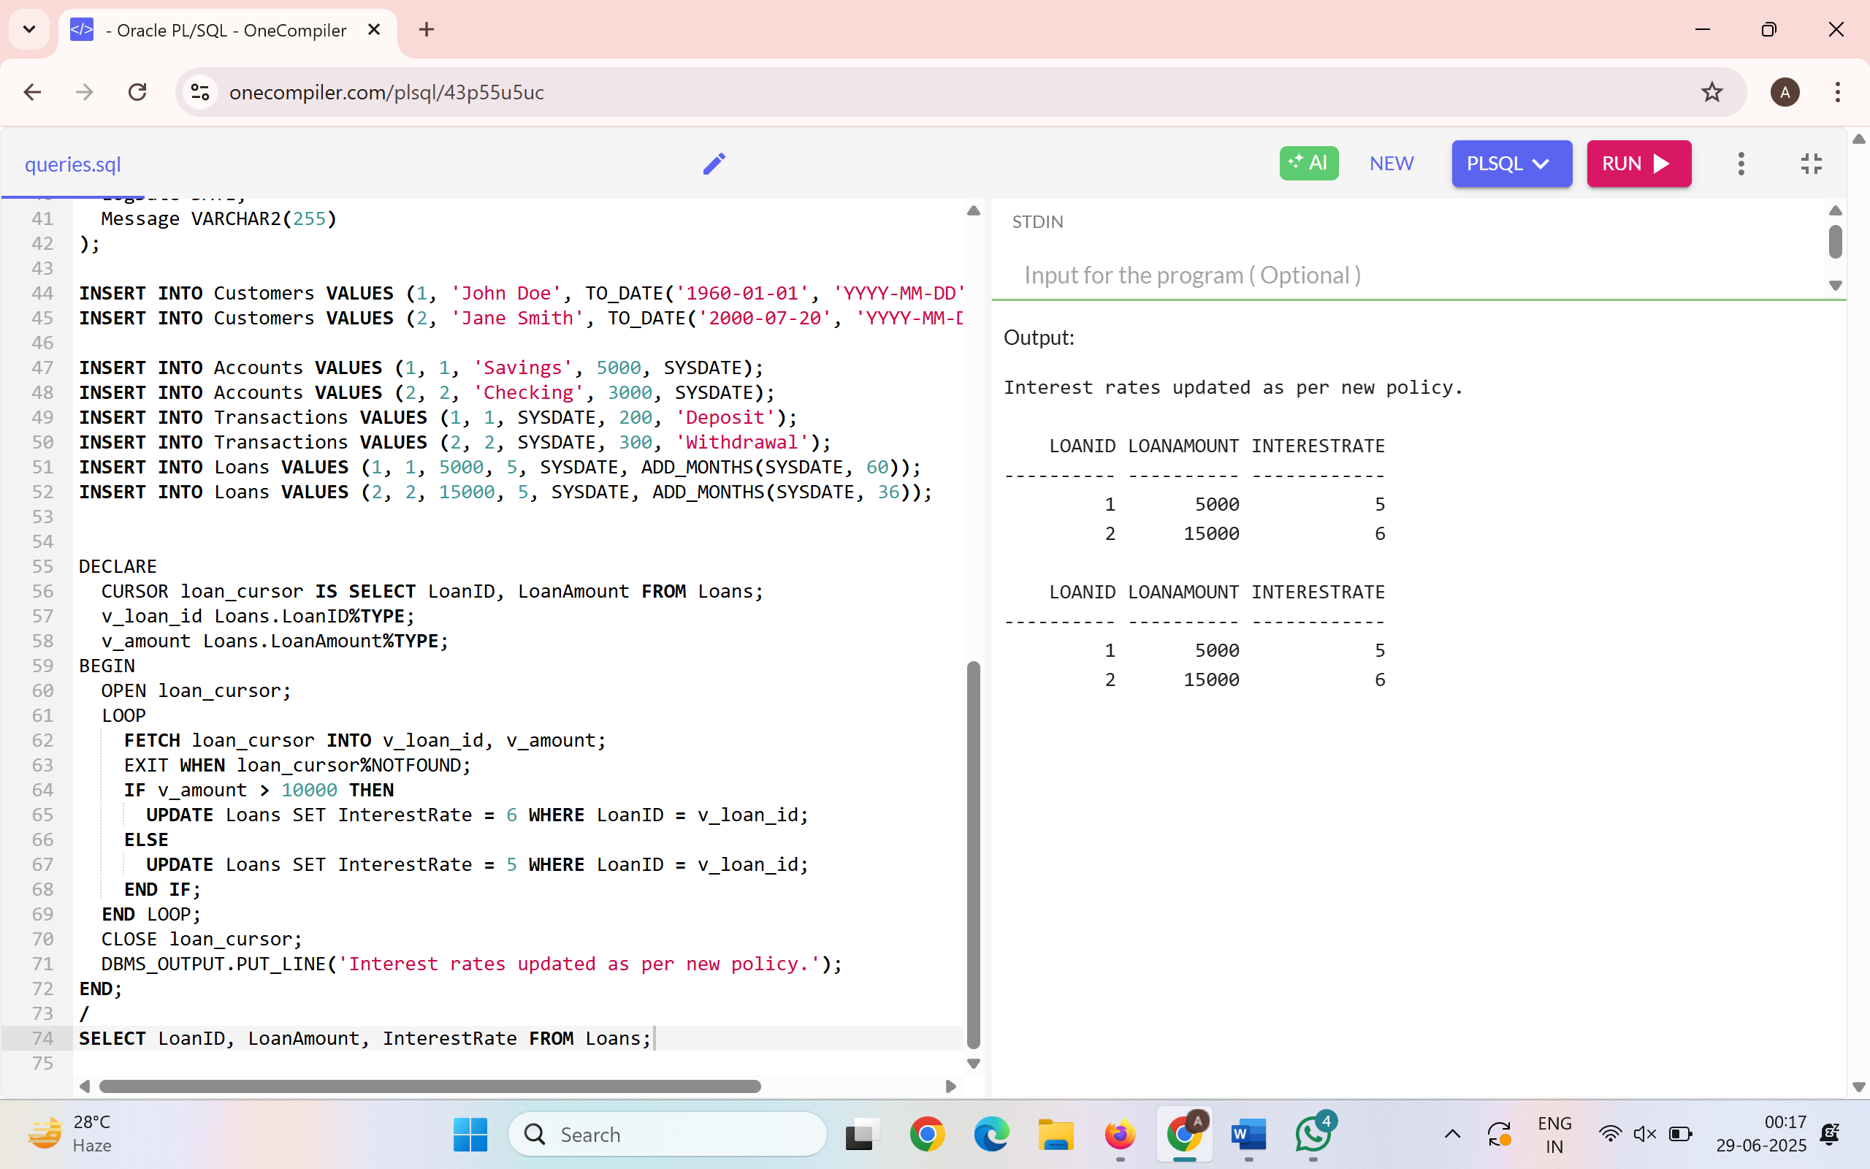

**Exercise 7: Packages**

**Scenario 1:** Group all customer-related procedures and functions into a package.

**Question:** Create a package **CustomerManagement** with procedures for adding a new customer, updating customer details, and a function to get customer balance.

**Query:**

CREATE OR REPLACE PACKAGE CustomerManagement AS

PROCEDURE AddCustomer(p_id NUMBER, p_name VARCHAR2, p_dob DATE, p_balance NUMBER);

PROCEDURE UpdateCustomer(p_id NUMBER, p_name VARCHAR2, p_balance NUMBER);

FUNCTION GetCustomerBalance(p_id NUMBER) RETURN NUMBER;

END CustomerManagement;

/

CREATE OR REPLACE PACKAGE BODY CustomerManagement AS

PROCEDURE AddCustomer(p_id NUMBER, p_name VARCHAR2, p_dob DATE, p_balance NUMBER) IS

BEGIN

INSERT INTO Customers VALUES (p_id, p_name, p_dob, p_balance, SYSDATE);

END;

PROCEDURE UpdateCustomer(p_id NUMBER, p_name VARCHAR2, p_balance NUMBER) IS

BEGIN

UPDATE Customers SET Name = p_name, Balance = p_balance, LastModified = SYSDATE WHERE CustomerID = p_id;

END;

FUNCTION GetCustomerBalance(p_id NUMBER) RETURN NUMBER IS

v_balance NUMBER;

BEGIN

SELECT Balance INTO v_balance FROM Customers WHERE CustomerID = p_id;

RETURN v_balance;

END;

END CustomerManagement;

/

BEGIN

DBMS_OUTPUT.PUT_LINE('Customer 1 Balance: ' || CustomerManagement.GetCustomerBalance(1));

END;

/

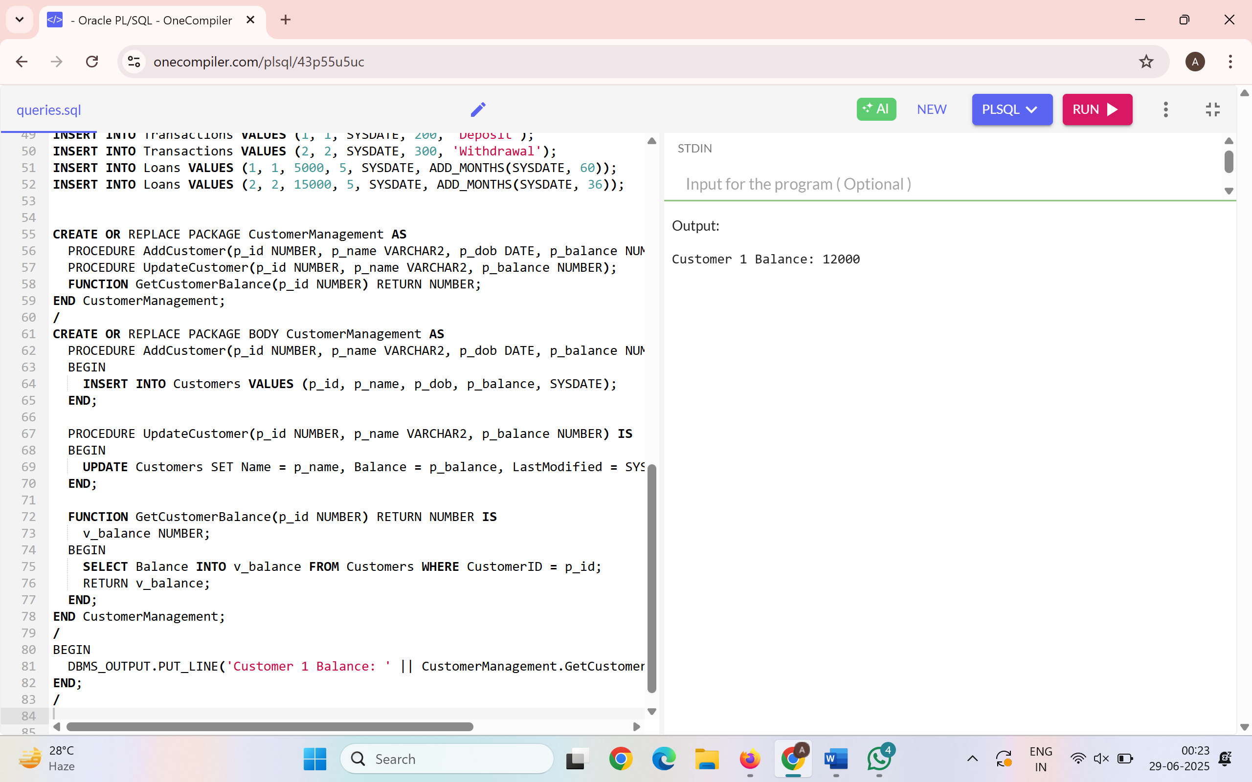

**Scenario 2:** Create a package to manage employee data.

**Question:** Write a package **EmployeeManagement** with procedures to hire new employees, update employee details, and a function to calculate annual salary.

**Query:**

CREATE OR REPLACE PACKAGE EmployeeManagement AS

PROCEDURE HireEmployee(p_id NUMBER, p_name VARCHAR2, p_position VARCHAR2, p_salary NUMBER, p_dept VARCHAR2);

PROCEDURE UpdateEmployee(p_id NUMBER, p_salary NUMBER);

FUNCTION GetAnnualSalary(p_id NUMBER) RETURN NUMBER;

END EmployeeManagement;

/

CREATE OR REPLACE PACKAGE BODY EmployeeManagement AS

PROCEDURE HireEmployee(p_id NUMBER, p_name VARCHAR2, p_position VARCHAR2, p_salary NUMBER, p_dept VARCHAR2) IS

BEGIN

INSERT INTO Employees VALUES (p_id, p_name, p_position, p_salary, p_dept, SYSDATE);

END;

PROCEDURE UpdateEmployee(p_id NUMBER, p_salary NUMBER) IS

BEGIN

UPDATE Employees SET Salary = p_salary WHERE EmployeeID = p_id;

END;

FUNCTION GetAnnualSalary(p_id NUMBER) RETURN NUMBER IS

v_salary NUMBER;

BEGIN

SELECT Salary INTO v_salary FROM Employees WHERE EmployeeID = p_id;

RETURN v_salary * 12;

END;

END EmployeeManagement;

/

BEGIN

DBMS_OUTPUT.PUT_LINE('Employee 1 Annual Salary: ' || EmployeeManagement.GetAnnualSalary(1));

END;

/

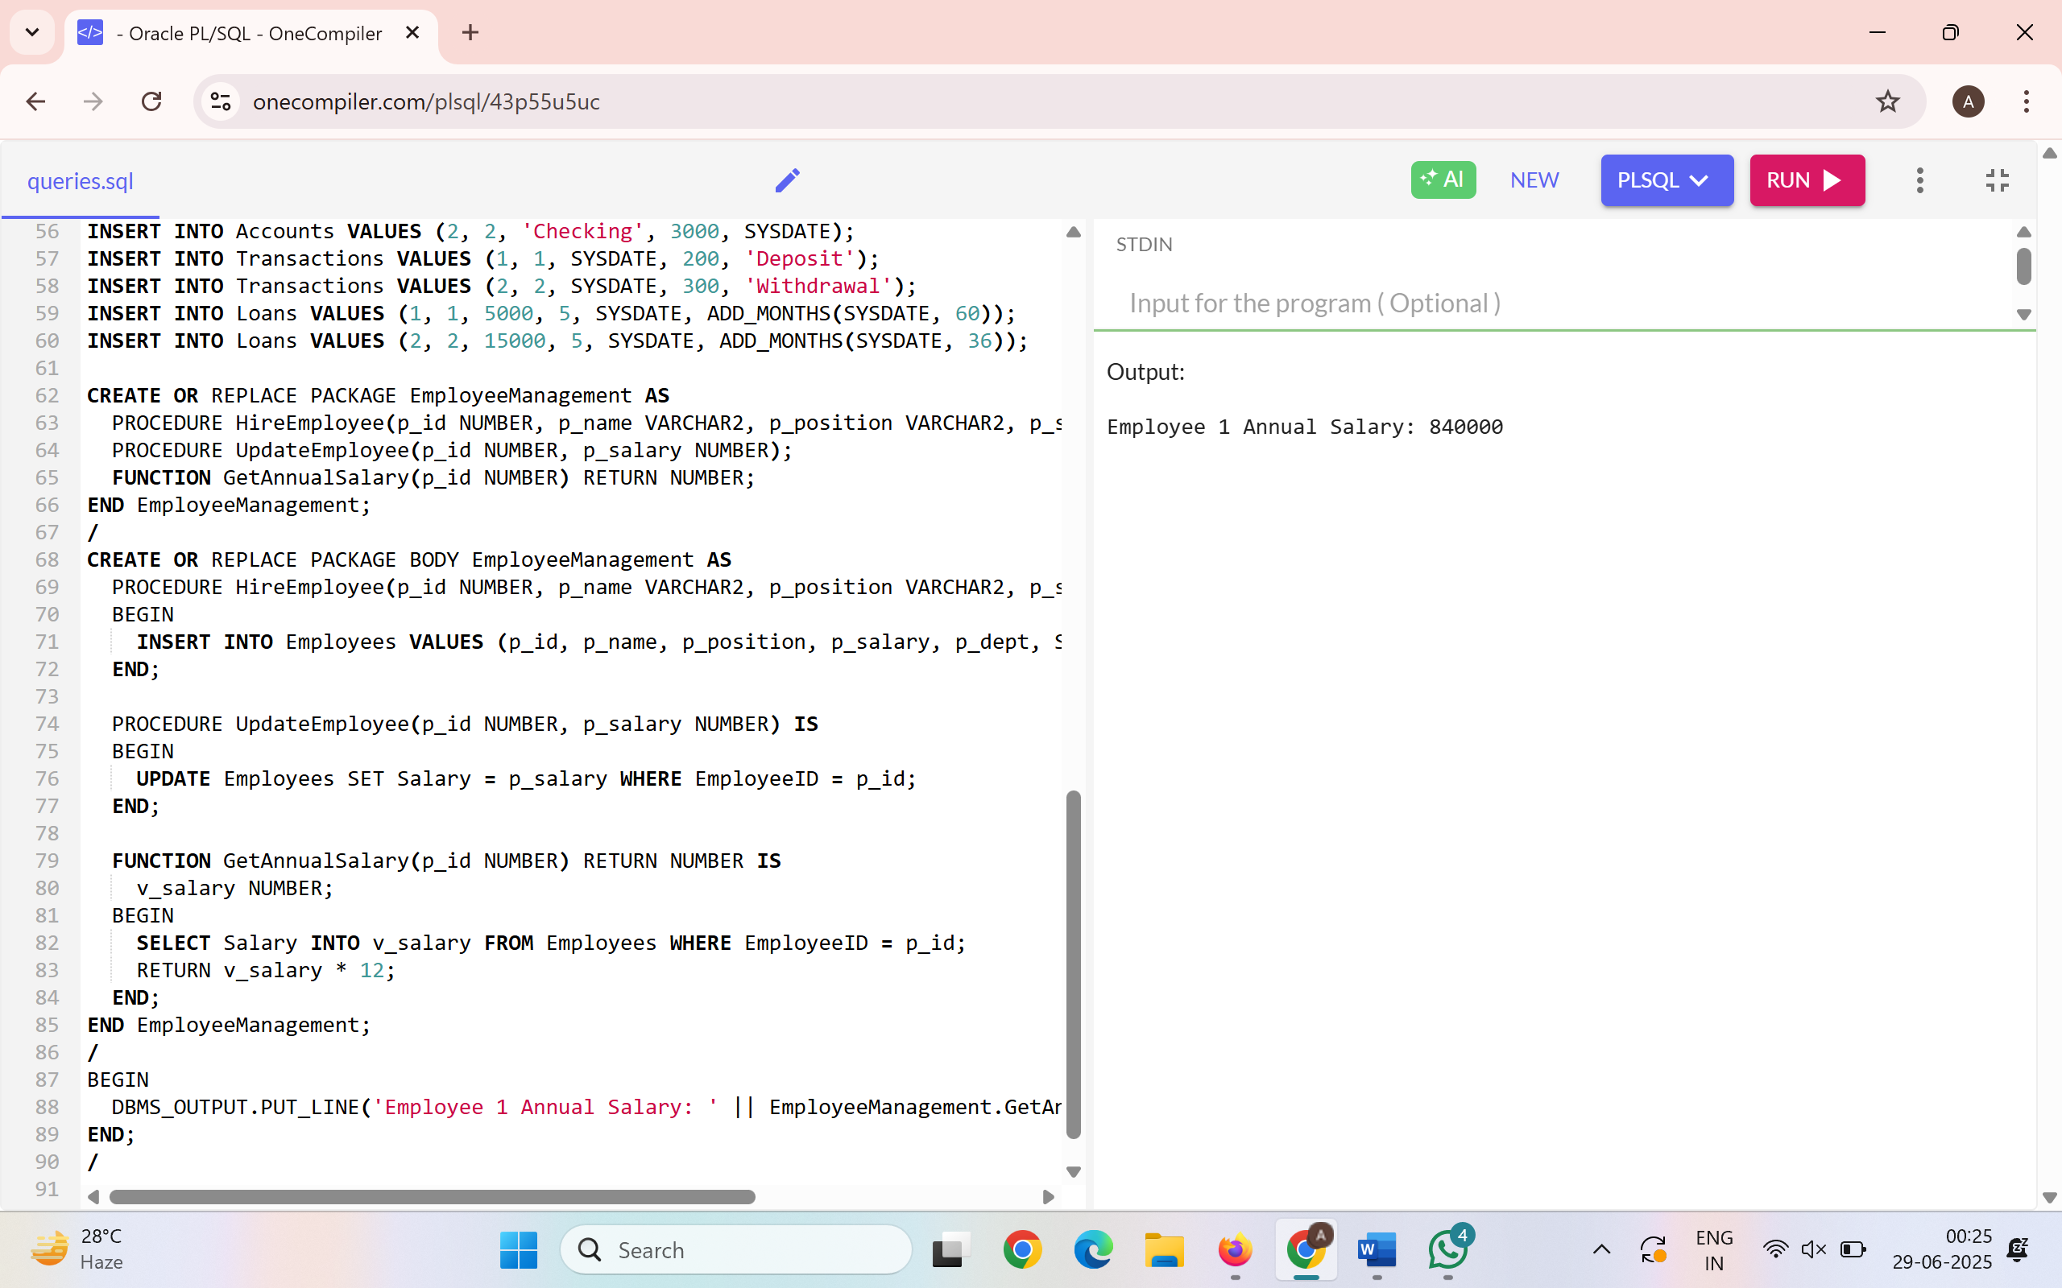

**Scenario 3:** Group all account-related operations into a package.

**Question:** Create a package **AccountOperations** with procedures for opening a new account, closing an account, and a function to get the total balance of a customer across all accounts.

**Query:**

CREATE OR REPLACE PACKAGE AccountOperations AS

PROCEDURE OpenAccount(p_id NUMBER, p_cust_id NUMBER, p_type VARCHAR2, p_balance NUMBER);

PROCEDURE CloseAccount(p_id NUMBER);

FUNCTION GetTotalBalance(p_cust_id NUMBER) RETURN NUMBER;

END AccountOperations;

/

CREATE OR REPLACE PACKAGE BODY AccountOperations AS

PROCEDURE OpenAccount(p_id NUMBER, p_cust_id NUMBER, p_type VARCHAR2, p_balance NUMBER) IS

BEGIN

INSERT INTO Accounts VALUES (p_id, p_cust_id, p_type, p_balance, SYSDATE);

END;

PROCEDURE CloseAccount(p_id NUMBER) IS

BEGIN

DELETE FROM Accounts WHERE AccountID = p_id;

END;

FUNCTION GetTotalBalance(p_cust_id NUMBER) RETURN NUMBER IS

v_total NUMBER;

BEGIN

SELECT SUM(Balance) INTO v_total FROM Accounts WHERE CustomerID = p_cust_id;

RETURN v_total;

END;

END AccountOperations;

/

BEGIN

DBMS_OUTPUT.PUT_LINE('Total Balance of Customer 1: ' || AccountOperations.GetTotalBalance(1));

END;

/

